

SOFTWARE ENGINEERING

**2024 MOD003263 TRI1 F01CAM**



**TEAM MEMBERS**

Francis Looby-Razzell

Faraz Ali   
 Aisiri Pradeep   
Note: Please read logbook

**Muhammad Ameer hamza**

010-2 Component Report  
  
Module Leader: Dr. Cristina Luca  
Course of Studies: Computer Science

# **Introduction**

The following report demonstrates the planning and development processes done primarily as a team in regard to the Community Relationship Management (CRM) software for Together Culture, as assigned for element 010-1 of Software Engineering.

Each team member contributed to creating a software solution designed to help Together Culture efficiently manage its growing member base and track engagement within the community. The CRM system aims to provide a secure platform where administrators can manage memberships, monitor activity trends, and support members in accessing resources and booking events.

# **1.** **Problem Definition Document**

## **1.1** **Case Study Description**

Together Culture is a Community Interest Company (CIC) that brings together individuals passionate about fostering a fair and sustainable creative economy. The organisation provides support, skills training, and a community for members who want to make a positive impact. Members benefit from various resources, leadership opportunities, and a collaborative environment to create change (Together Culture, n.d).

Currently, Together Culture relies on a manual system to track members and manage events, which is time-consuming and lacks the flexibility needed to analyse member engagement and trends. A CRM system will enable Together Culture to efficiently manage member data, improve user engagement, and gain valuable insights into member behaviour.

## **1.2** **Current System Description**

Together Culture’s existing system for managing membership and engagement data is entirely manual. This involves tracking data in spreadsheets or physical records, which limits the ability to:

1. Quickly retrieve member information or insights about community trends.

2. Efficiently manage member registrations, profiles, and engagement histories.

3. Track individual members’ participation in events and their progression in the community.

4. Provide personalised experiences and recommendations for members.

This manual process makes it challenging for administrators to monitor activity, organise events, and understand community engagement. It also limits the company’s ability to adapt to its members.

## **1.3** **Project Aims**

The primary goals of the CRM project are:

1. To create a centralised, digital CRM platform that securely stores member data and allows quick access for administrators.

2. To enable Together Culture to monitor member engagement and trends, allowing data-driven decision-making.

3. To provide members with an engaging, personalised experience through a secure dashboard where they can view and manage their activity, book events, and explore community resources.

4. To support community growth and connectivity by offering personalised activity recommendations and a digital space for skill exchanges and connections.

## **1.4** **Requirements**

Together Culture’s CRM will include several core and additional requirements to support its members and administrative team effectively.

For core functionality, the CRM should support data analysis capabilities, allowing the organisation to perform data mining to identify trends and track each member’s journey within the community. Members should have access to a personalised dashboard where they can view a summary of their usage of various benefits. This dashboard should feature a tag-based search capability that enables administrators to monitor community trends and access specific member or event data efficiently. User authentication should ensure a secure, password-protected environment where members can safely log in to access their profiles and benefits.

Membership management should allow administrators to add new members, assign one of three membership types (Community Members, Key Access Members, Creative Workspace Members), and update member preferences based on engagement levels or interests. Event and member tracking should let administrators monitor attendance at events and search by specific dates or event types, offering insights into engagement and attendance patterns. New users should be able to express interest in membership by creating profiles, which administrators will review and approve. Additionally, members should be able to book and access digital content modules, enhancing their engagement with Together Culture’s offerings. Members should also have the ability to view profile information, such as their expressed interests and initial motivations, which helps them track their progress and stay aligned with their goals.

In addition to these core features, the CRM should include some “nice-to-have” features that enhance the member experience. Members should receive personalised event suggestions based on past activities, encouraging continued involvement in relevant community events. A digital connections board should allow members to exchange skills or services as part of Together Culture’s timebank and skills library, fostering collaboration within the community. Finally, document access and messaging capabilities should enable members to view important community documents and connect with one another, creating a more cohesive and interactive online community space.

These requirements together aim to improve administrative efficiency, deepen member engagement, and support the sustainable growth of Together Culture’s mission.

## **1.5** **List of User Stories**

Reading the case study from Together Culture, each member contributed three user stories each:

1. As an administrator, I want to add members to the system so that I can track their engagement after they sign up. (Ameer)
2. As an administrator, I want to search for individual members and non-members to see all the events and visits they’ve made to Together Culture. (Ameer)
3. As an administrator, I want to search for specific events or time periods to see how many guests attended and identify who those guests were. (Ameer)
4. As an administrator, I want to create tags that are visible on the dashboard and searchable in a database to identify activity trends and gain insights about member behaviour. (Francis)
5. As an administrator, I want to differentiate between membership types to manage them effectively. (Francis)
6. As an administrator, I want to monitor new members joining and progressing through our Community Journey to analyse their engagement over time. (Francis)
7. As an administrator, I want to authorise members who express interest in joining by creating a profile to ensure they meet our community standards. (Aisiri)
8. As a member, I want to view and book the full series of digital content modules so I can enhance my learning and involvement. (Aisiri)
9. As a member, I want to see a dashboard view of the benefits I am using and those I have not utilised, helping me understand the value of my membership. (Aisiri)
10. As a member, I want to access the information I provided about my interests and intentions during my orientation to stay aligned with my goals. (Faraz)
11. As a user, I want to log into a password-protected members-only area to securely access my account and information. (Faraz)
12. As a user, I want to express my interest in becoming a member by creating a profile that requires administrator approval. (Faraz)
13. As a user, I would like to view what events are being hosted and where so that I may book a ticket for the event and attend it. (Francis)

## **1.6** **Project Plan**

Software Application described in the report is created according to the agile software lifecycle. In more details, the process acts according to the Agile methodology since, as mentioned in the Agile Manifesto (agilemanifesto.org, 2001), it allows an active collaboration within team members and a good adaptability to new system requirements.

We aim to complete the project in set phases:

a) **Requirement Gathering and Analysis (1-2 weeks):** In this phase, we will define the detailed requirements of the CRM system, complete the user stories, and finalise the resources needed for the project.

b) **Design Phase (2 weeks):** During this time, we will create wireframes, diagrams to show how the data will be organised, and UML diagrams, which include use case, class, and sequence diagrams to represent system interactions.

c) **Development (4 weeks):** In this phase, we will build the main features of the CRM, which includes the front-end user interface, back-end server functions, and the database for storing information.

d) **Testing and Quality Assurance (2 weeks):** We will test each feature to ensure it works correctly, is user-friendly, and fix any bugs that may arise.

e) **Deployment and Maintenance Planning (1 week):** Finally, we will launch the system and create a maintenance plan to support the software over the long term.

## **1.7** **Resources**

The following resources will be used in completing the project:

* + - Google Chrome web browser, version (130.0.6723.70)
    - Microsoft Word, version 2016 for Windows
    - Microsoft Excel version 2016 for Windows
    - GitHub version 3.4.8
    - Visual Studio 1.94 version
    - Visual Paradigm/Draw.io/Lucid Chart
    - XAMPP

**2.** **Software Design**

## **2.1** **Wireframes**

**Wireframe for Dashboard:**

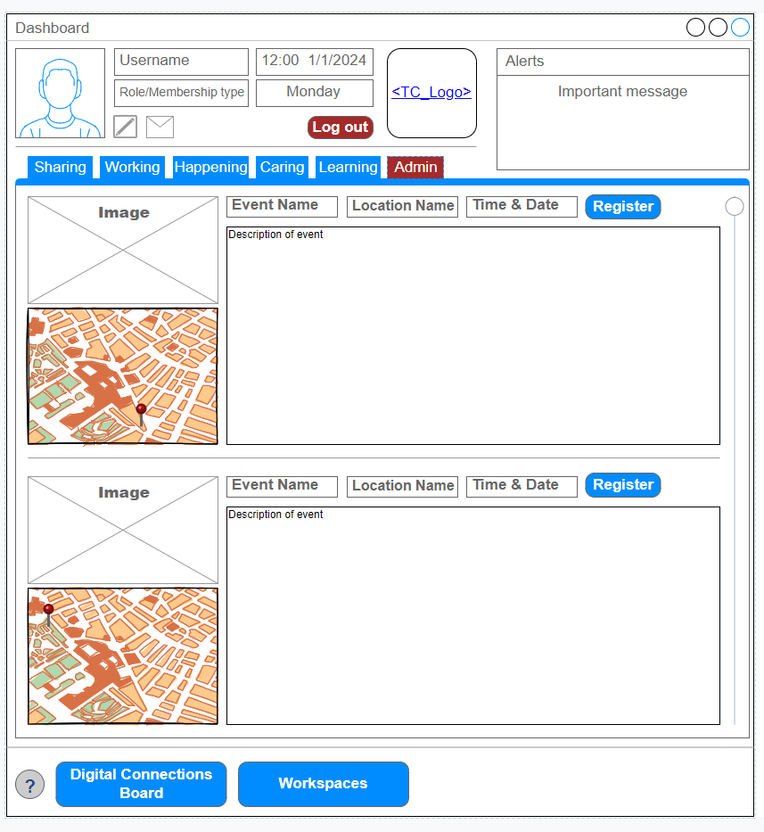

## This wireframe represents the main **Dashboard** interface.

## **Top Section**: Includes the username, role/membership type, current time, date, and an alert section.

## **Navigation Tabs**: Provides options like *Sharing, Working, Happening, Caring, Learning,* and *Admin* for different categories.

## **Event Display**:

## Shows two event slots.

## Each slot contains an event image, event name, location name, time/date, and a "Register" button.

## A description of the event is provided.

## **Bottom Navigation**: Buttons for *Digital Connections Board* and *Workspaces*.

**

## This wireframe shows the **Login Interface** for users:

## **Left Section**: Displays a logo placeholder.

## **Right Section**: Contains login components:

## A welcome message.

## A dropdown to select the role (e.g., Admin).

## Username and password input fields.

## A "Login" button for authentication.

## 

## **Logout Form Wireframe:**A screenshot of a computer Description automatically generated This wireframe displays the **Logout Interface**:

## **Left Section**: Side navigation menu includes options such as:

## *Dashboard, Add Member, Manage Events, Reports, Settings,* and *Logout*.

## **Main Section**:

## Displays a confirmation message: *"Are you sure you want to logout?"*.

## A "Logout" button to proceed.

## **Admin Dashboard Wireframe**: A screenshot of a computer Description automatically generated This wireframe represents the **Admin Dashboard Interface**:

## **Left Section**: Side navigation menu with options:

## *Dashboard, Add Member, Manage Events, Reports, Settings,* and *Logout*.

## **Top Section**: Highlights two main insights: *Insights* and *Members Data*.

## **Main Content**: A data display area for admin-specific content.

## 

## **Registration Form Wireframe**:A screenshot of a login form Description automatically generated This wireframe shows the **User Registration Interface**:

## **Left Section**: Displays a logo placeholder.

## **Right Section**: Includes registration fields:

## *Full Name, Username, Password,* and *Confirm Password*.

## A "Register" button to submit details.

## **Footer**: A link for users who already have an account to "Login Here".

## 

## **Add Member Form Wireframe:**

## This wireframe displays the **Add Member Interface**:

## **Left Section**: Side navigation menu with admin options such as *Dashboard, Add Member, Manage Events, Reports, Settings,* and *Logout*.

## **Main Section**:

## Contains fields to add a new member: *Full Name, Username, Password,* and *Confirm Password*.

## A "Submit" button to finalize the process.

## **Settings Form Wireframe:**

## This wireframe represents the **Settings Interface**:

## **Left Section**: Side navigation menu for admin tasks.

## **Main Section**: Includes the following features:

## **Update Password**: Input field with an "Update" button.

## **Theme Selection**: Dropdown to select themes (e.g., Light).

## **Database Management**: Buttons for *Backup Database* and *Restore Database*.

## **Version Control**: Displays "Latest Version" information.

## A "Save" button to apply changes.

## 

## **2.2** **Database Design**

### **2.2.1** **Entity Relationship Diagram**

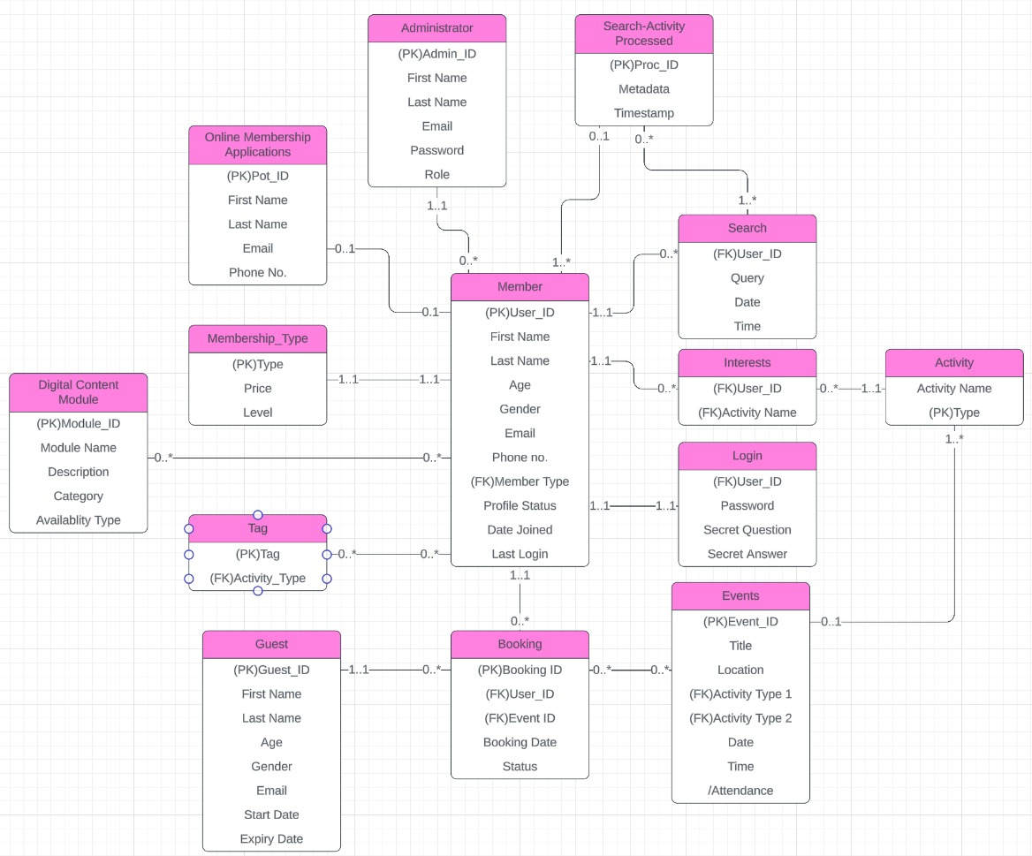

This Entity-Relationship Diagram (ERD) represents a database for a membership-based system that manages users, activities, bookings, and digital content. At the core of the system is the **Member** entity, which stores user details such as name, age, email, phone number, and their membership type. Members can log in using credentials stored in the **Login** table, search for content through the **Search** table, and express their preferences in the **Interests** table by associating activities with their profiles. Members can also book events, which are tracked in the **Booking** table and linked to the **Events** entity. Events include attributes like title, location, date, and time, and they are associated with specific activities via the **Activity** table.

The system also supports **Guest** users, who share similar attributes with members but have a limited timeframe for access. **Online Membership Applications** allow new users to apply for memberships, and administrators manage these applications and oversee system operations through the **Administrator** table. Additionally, the **Search-Activity Processed** table stores metadata and timestamps related to searches, enabling further insights into user activities.

**Entities and Attributes**

1. Administrator
   * Primary Key (PK): Admin_ID
   * Attributes: First Name, Last Name, Email, Password, Role
2. Member
   * Primary Key (PK): User_ID
   * Attributes: First Name, Last Name, Age, Gender, Email, Phone no., Profile Status, Date Joined, Last Login
   * Foreign Key (FK): Member Type
3. Guest
   * Primary Key (PK): Guest_ID
   * Attributes: First Name, Last Name, Age, Gender, Email, Start Date, Expiry Date
4. Online Membership Applications
   * Primary Key (PK): Omt_ID
   * Attributes: First Name, Last Name, Email, Phone No.
5. Membership_Type
   * Primary Key (PK): Type
   * Attributes: Price, Level
6. Booking
   * Primary Key (PK): Booking_ID
   * Attributes: Booking Date, Status
   * Foreign Keys (FK): User_ID, Event_ID
7. Events
   * Primary Key (PK): Event_ID
   * Attributes: Title, Location, Date, Time, Attendance
   * Foreign Keys (FK): Activity Type 1, Activity Type 2
8. Search-Activity Processed
   * Primary Key (PK): Proc_ID
   * Attributes: Metadata, Timestamp
9. Search
   * Foreign Key (FK): User_ID
   * Attributes: Query, Date, Time
10. Interests
    * Foreign Keys (FK): User_ID, Activity Name
11. Activity
    * Primary Key (PK): Type
    * Attributes: Activity Name
12. Login
    * Foreign Key (FK): User_ID
    * Attributes: Password, Secret Question, Secret Answer
13. Digital Content Module
    * Primary Key (PK): Module_ID
    * Attributes: Module Name, Description, Category, Availability Type
14. Tag
    * Primary Key (PK): Tag

## 

## **2.3** **Use case diagram**

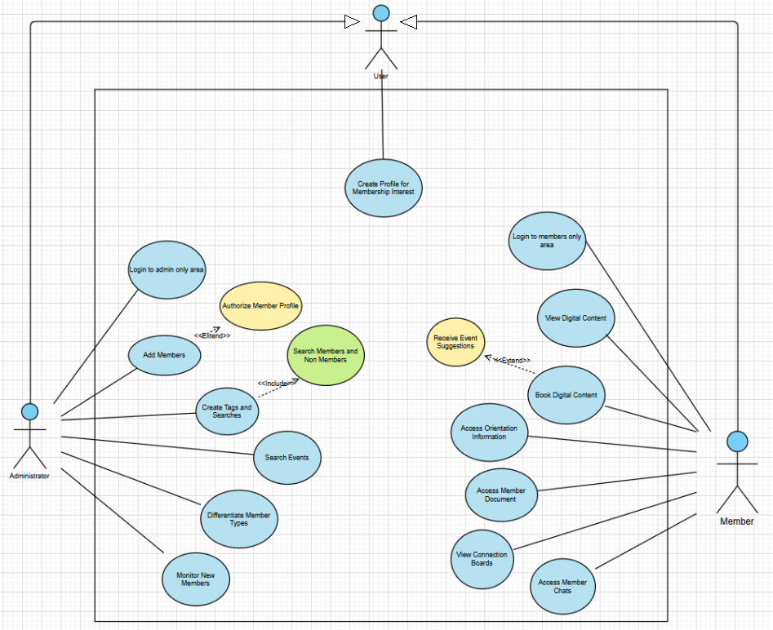Here’s the description of the use cases:

| **Use Case Name** | **Actors** | **Flow of Events** | **Alternative Flows** | **Entry Conditions** | **Exit Conditions** |
| --- | --- | --- | --- | --- | --- |
| **Create Profile for Membership Interest** | User | 1. User navigates to the membership interest page.2. Fills in profile details.3. Submits the form.4. Confirmation message displayed. | 3a. Mandatory fields left empty; error displayed.3b. Invalid email format; error displayed. | User is on the membership interest page. | Profile successfully submitted or action canceled. |
| **Authorize Member Profile** | Administrator | 1. Admin logs into the admin area.2. Views pending profiles.3. Approves or rejects profiles.4. Confirmation of action displayed. | 3a. Admin requests additional details.3b. Admin rejects profile without action. | Admin is logged into the admin area. | Profiles are either approved or rejected. |
| **Login to Members Only Area** | Member | 1. Member enters login credentials.2. Clicks "Login".3. Members-only area opens. | 2a. Incorrect credentials; error displayed.2b. Clicks "Forgot Password" for recovery. | Member has valid login credentials. | Successful login to members-only area or action canceled. |
| **Search Members and Non-Members** | User, Administrator | 1. User/Admin navigates to the search page.2. Enters search criteria.3. Results displayed. | 2a. Search returns no results; error displayed. | User/Admin is on the search page. | Search results displayed or no matches found. |
| **Book Digital Content** | Member | 1. Member selects digital content.2. Clicks "Book".3. Payment options displayed.4. Completes booking.5. Confirmation displayed. | 3a. Payment failed; error displayed.3b. User cancels booking. | Member is logged into the members-only area. | Content booked successfully or action canceled. |
| **Monitor New Members** | Administrator | 1. Admin views a list of new members.2. Monitors engagement progress.3. Takes necessary action (e.g., guidance, warnings). | 2a. No actions required for members. | Admin is logged into the admin area. | New members' activities reviewed and monitored. |
| **Receive Event Suggestions** | User | 1. User receives event recommendations.2. Clicks on suggestions.3. Registers for events of interest. | 3a. User ignores event suggestions. | User has an active profile for membership interest. | Event suggestions are displayed or ignored. |
| **Access Orientation Information** | Member | 1. Member accesses the orientation section.2. Views personal interest details.3. Updates information.4. Saves changes. | 3a. Member cancels updates; no changes saved. | Member is logged into the members-only area. | Orientation information accessed or updated successfully. |
| **View Digital Content** | Member | 1. Member navigates to the digital content section.2. Browses the available content.3. Selects content to view. | 2a. No content available; error displayed. | Member is logged into the members-only area. | Digital content viewed or action canceled. |
| **Differentiate Member Types** | Administrator | 1. Admin views the membership type list.2. Filters members by type.3. Views sorted membership data. | 3a. No members for the selected type; error displayed. | Admin is logged into the admin area. | Membership data filtered and reviewed. |
| **Add Members** | Administrator | 1. Admin opens the "Add Members" section.2. Reviews new member requests.3. Approves or rejects requests. | 3a. No pending requests; notification displayed. | Admin is logged into the admin area. | New members added to the system or rejected. |
| **Create Tags and Searches** | Administrator | 1. Admin creates new tags or searches.2. Tags/Searches are saved in the database.3. Tags/Searches displayed on the dashboard. | 2a. Duplicate tags; error displayed. | Admin is logged into the admin area. | Tags and searches successfully created or action canceled. |
| **Search Events** | Administrator | 1. Admin searches events by criteria (e.g., type, time).2. Retrieves event attendance data.3. Views event details. | 2a. No events match the criteria; error displayed.3a. Admin clears the search. | Admin is logged into the admin area. | Event details displayed or search canceled. |
| **Access Member Documents** | Member | 1. Member navigates to the documents section.2. Views or downloads documents. | 2a. No documents available; error displayed. | Member is logged into the members-only area. | Member documents accessed or action canceled. |
| **Access Member Chats** | Member | 1. Member navigates to the chat section.2. Starts a new chat or joins an existing one.3. Sends/receives messages. | 2a. No active chats; error displayed. | Member is logged into the members-only area. | Chat messages exchanged or chat action canceled. |
| **View Connection Boards** | Member | 1. Member navigates to the connection boards.2. Views offers and requests from other members.3. Posts or replies to listings. | 3a. No listings available; error displayed. | Member is logged into the members-only area. | Connection board accessed, and interactions performed or canceled. |

## **2.4** **Class diagram**

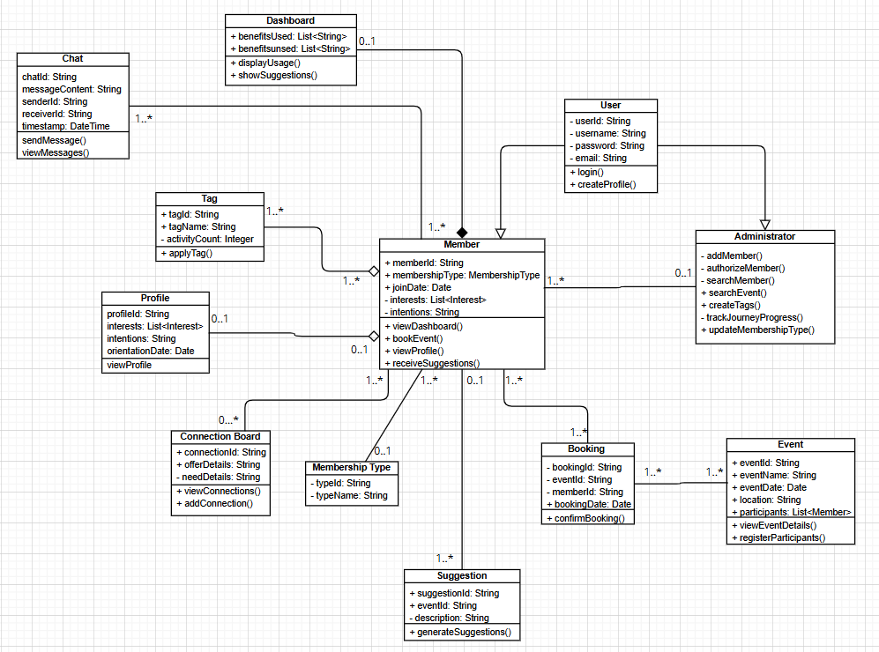

## **Class Diagram Description:** Based on the requirements, the diagram is composed of **10 classes**, representing both front-end and back-end components. These classes encapsulate the attributes and methods required to fulfill the functionalities defined in the user stories from the document. **Front-End Classes**:

## Dashboard: Provides methods like displayUsage() and showSuggestions() to display personalized recommendations and track the benefits utilized by members.

## Profile: Includes attributes such as interests and intentions that reflect a member’s personal preferences. The viewProfile() method allows members to access their profile details.

## Chat: Contains attributes like messageContent and timestamp, and methods like sendMessage() and viewMessages() to enable communication between members.

## Connection Board: Implements methods like viewConnections() and addConnection() for members to offer or request skills and services, fostering collaboration.

## Suggestion: Generates event or activity recommendations using the generateSuggestions() method, based on member preferences and past activities.

## **Back-End Classes**:

## User: Serves as the base class for all users, including members and administrators. It contains core attributes like userId, username, and methods for user authentication such as login() and createProfile().

## Member: Extends the User class and includes specific attributes like membershipType, joinDate, and intentions. Members can perform actions such as booking events (bookEvent()) or viewing their dashboard (viewDashboard()).

## Administrator: Handles administrative tasks with methods like addMember(), authorizeMember(), and updateMembershipType(), enabling effective management of members and system data.

## Booking: Links members to events, with attributes like bookingId and eventId. The confirmBooking() method ensures event registration is processed.

## Event: Represents community events with attributes like eventName, eventDate, and participants. The viewEventDetails() and registerParticipants() methods allow administrators to manage event information.

## Each class reflects the database structure by including attributes necessary for storing information and methods for manipulating or retrieving this data. For example:

## The Tag class represents a mechanism for administrators to categorize and track activities, as seen in methods like applyTag().

## The MembershipType class defines the types of memberships available, ensuring members are managed effectively.

## All classes are designed to interoperate seamlessly:

## The **relationships** between classes align with the functional dependencies of the system, such as the many-to-one relationship between Member and Booking, or the association between Event and Booking.

## Methods like searchMember() in Administrator and receiveSuggestions() in Member directly address the requirements defined in the project documentation.

## This diagram serves as the blueprint for implementing the CRM system, ensuring each user story is addressed with a well-defined structure. Let me know if you need further refinement or additional details!

## **2.5** **Sequence diagram**

### **2.5.1** **User story 1**

In figure,

1. The Admin sends an "Add Member Request" to the System to add a new member to the system.
2. The System forwards the new member's details to the Database for storage.
3. The Database confirms that the new member details have been saved successfully and returns a confirmation message to the System.
4. Once the member's information is saved, the System sends a request to the Engagement Tracker to begin tracking engagement for the newly added member.
5. The Engagement Tracker logs an initial engagement record for the member in the Database, setting up the baseline for future engagement tracking.
6. The Database confirms to the Engagement Tracker that the initial engagement log has been recorded.
7. The Engagement Tracker sends a confirmation to the System that engagement tracking is set up for the new member.
8. The System returns a final confirmation message to the Admin, confirming that the member has been successfully added and is now set up for engagement tracking.

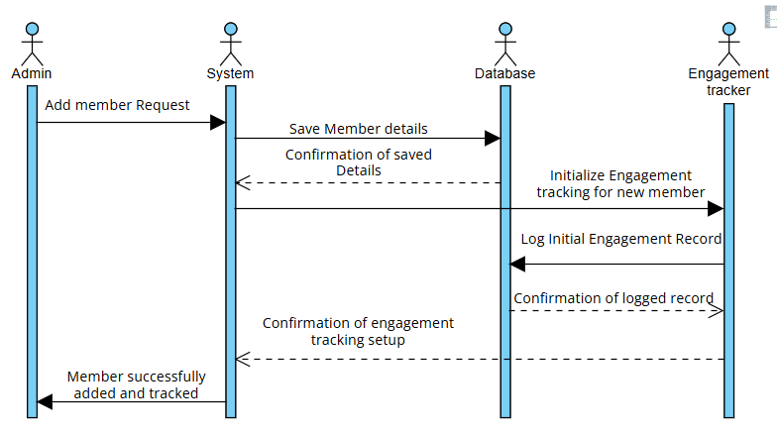

### 

### **2.5.2** **User story 2**

In figure,

1. The Admin sends a search request to the System with details of the individual they want to look up (could be a member or non-member).
2. The System sends a request to the Database to retrieve details of the specified individual, including their membership status, events attended, and visits made to Together Culture.
3. The Database searches for records associated with the individual, including any events they’ve attended and visits logged.
4. Once the data retrieval is complete, the Database returns the relevant information (events and visits) for the searched individual back to the System.
5. The System formats and displays all available information for the individual to the Admin, including their event participation and visits.

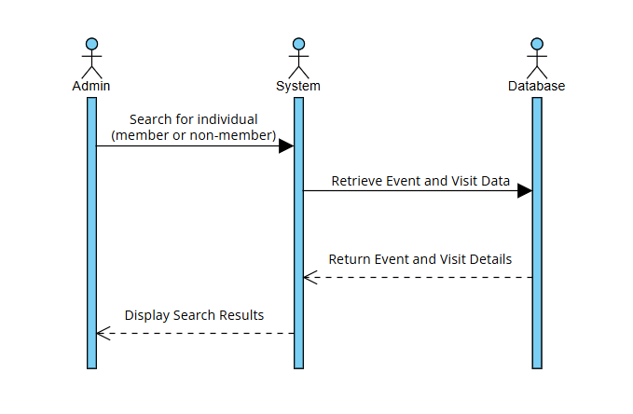

### **2.5.3** **User story 3**

In figure,

1. Administrator requests to search for specific events or time periods (e.g., date ranges or event IDs).
2. The system asks the Administrator to provide event criteria, such as the event ID, date range, or other search parameters.
3. Administrator then submits the necessary search criteria, which could include the event's specific date or time period, to the System.
4. System queries the Database for matching events and corresponding guest information based on the provided parameters.
5. Database responds by retrieving the event and guest data matching the search criteria and returns it to the System.
6. The system processes it, counting the number of guests and identifying individual guests who attended the event(s) during the specified time period. This is represented by a self-message (internal action) within the System.
7. The system displays the processed information (event details, guest count, and guest identities) back to the Administrator.

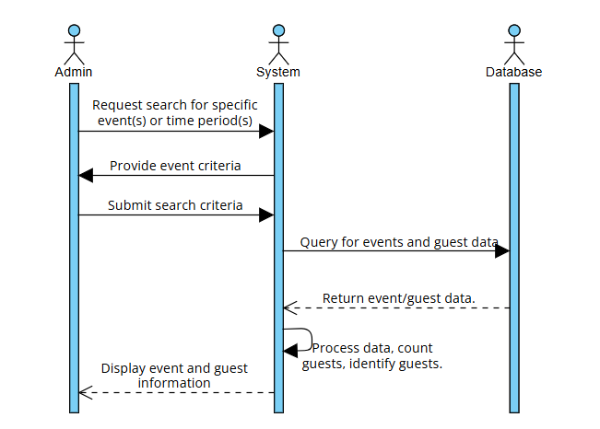

### 

### 

### 

### 

### 

### 

### 

### 

### 

### 

### 

### 

### **2.5.4** **User story 4**

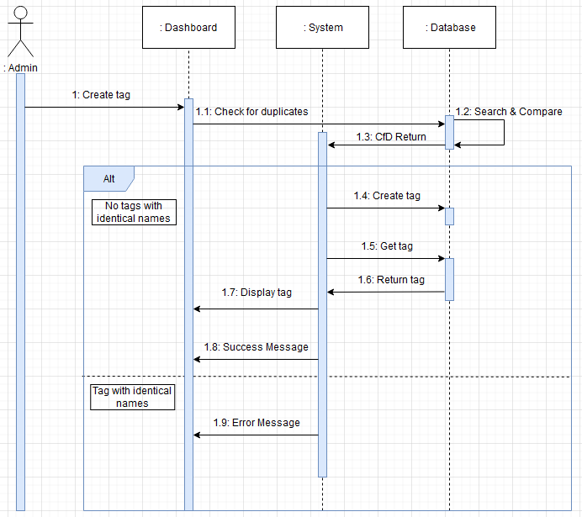

### 

### **2.5.5** **User story 5**

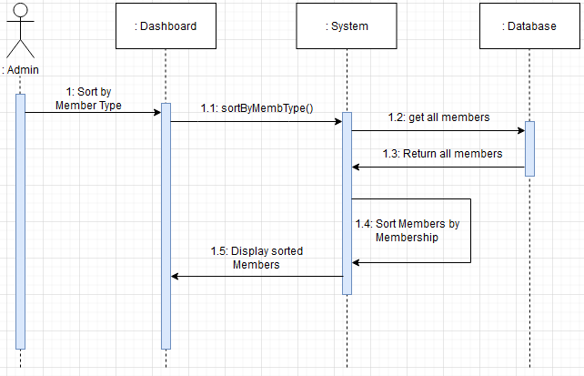

### 

### 

### 

### 

### 

### 

### 

### 

### 

### 

### **2.5.6** **User story 6**

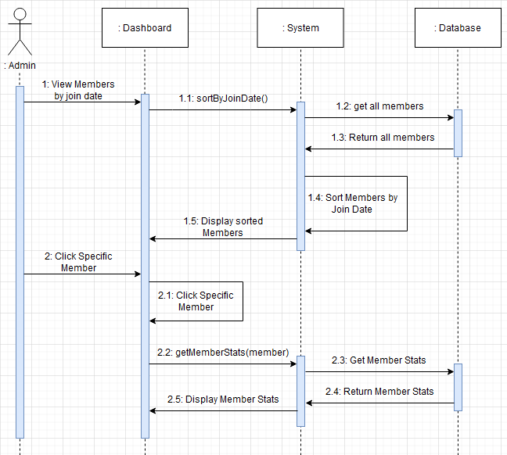

### 

### **2.5.7** **User story 7**

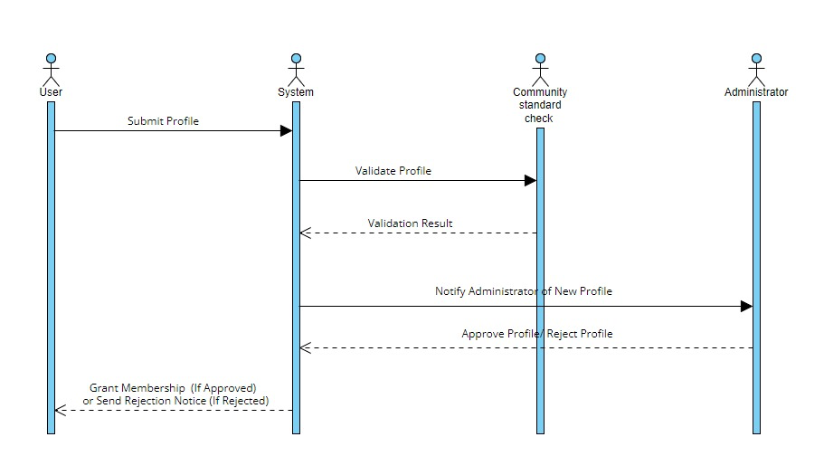

### 

### 

### 

### 

### 

### 

### 

### 

### 

### 

### 

### 

### 

### 

### 

### 

### 

### **2.5.8** **User story 8**

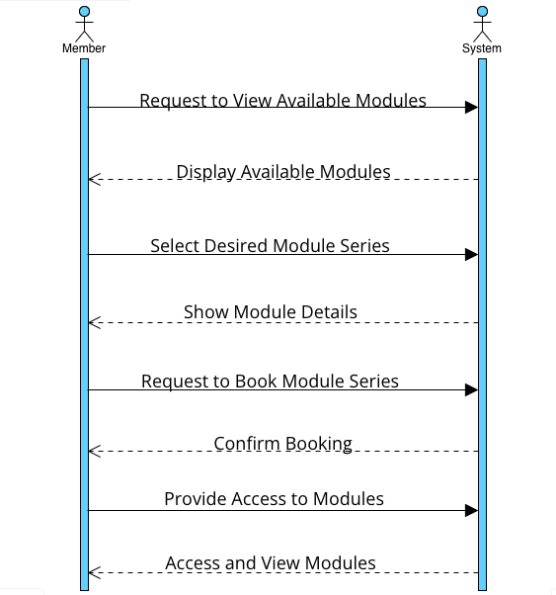

### 

### **2.5.9** **User story 9**

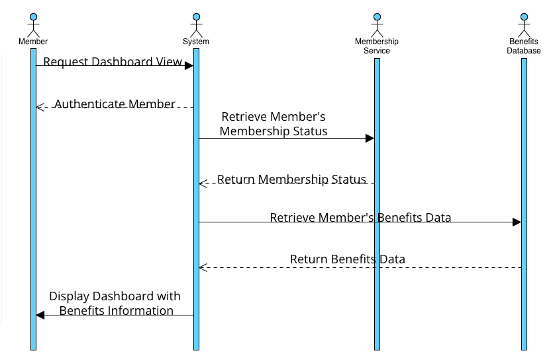

### 

### **2.5.10** **User story 10**

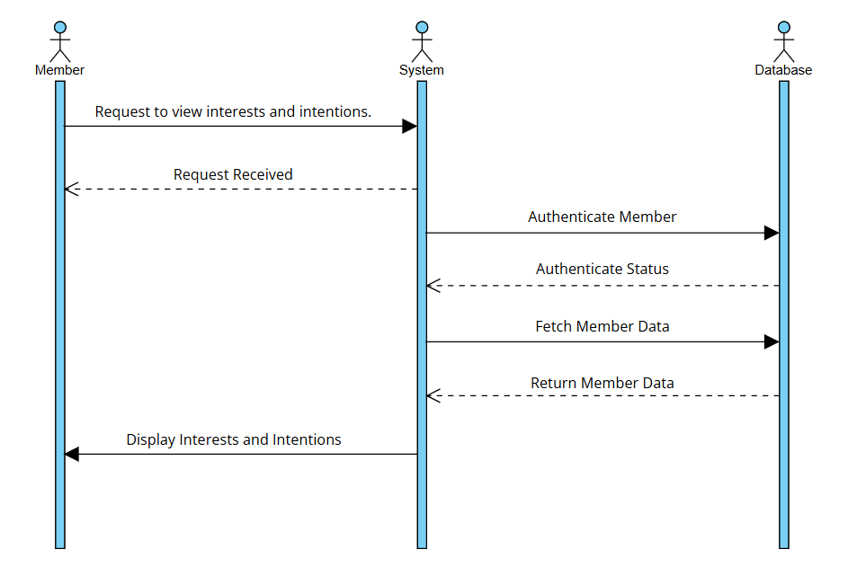

### 

### **2.5.11** **User story 11**

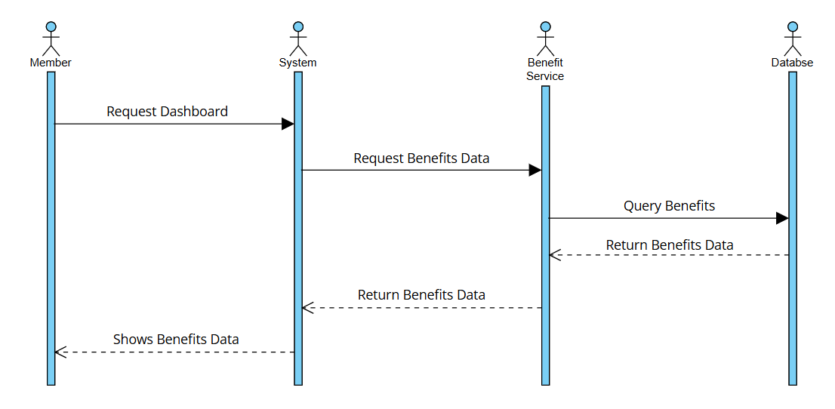

### 

### **User story 12**

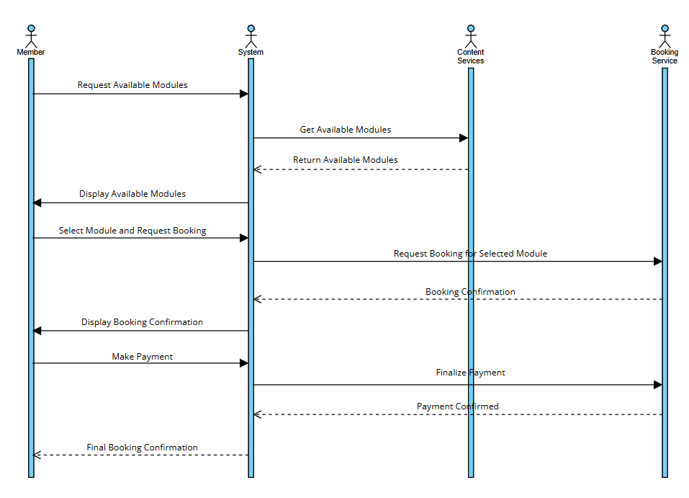

# 3. Software Development Documentation:

## 3.1 Personal User Stories:

### 3.1.1 User Story 1:

*“As an administrator, I want to add members to the system so that I can track their engagement after they sign up.”*

The administrator would sign in to the system using the credentials. Admin needs to enter email and password for the validation.

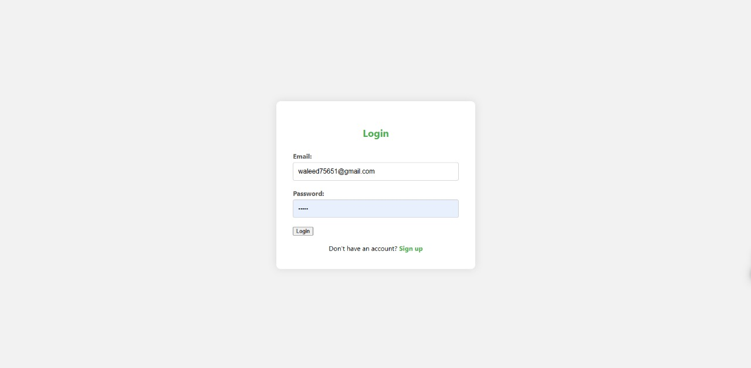

If email or password for the administrator is wrong, the administrator would not be able to access the admin dashboard.

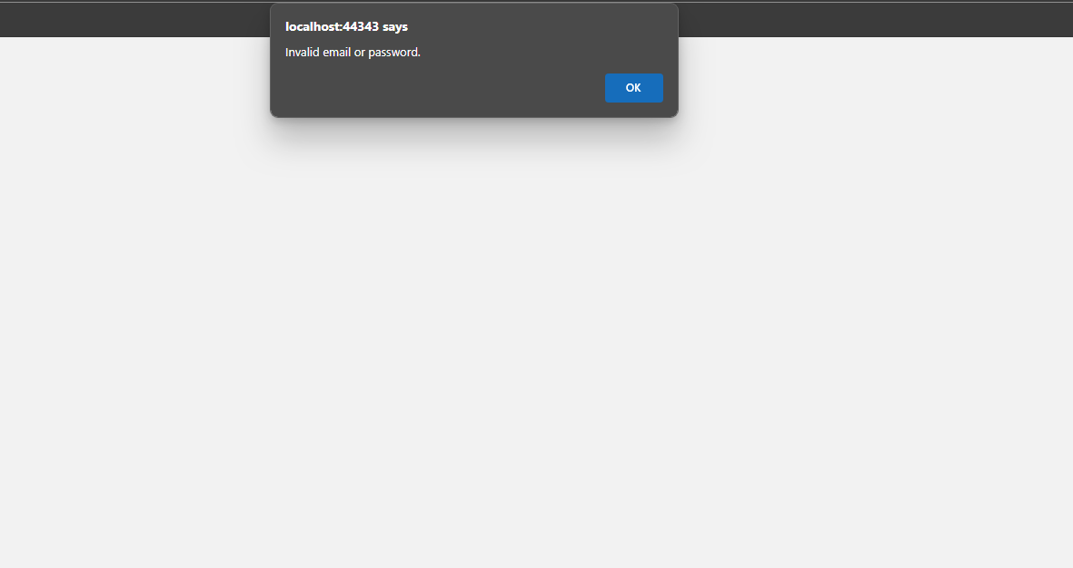

If the email and password are correct, the administrator would be able to access the dashboard. The administrator would be able to add the members, search the members, differentiate member types, and monitor new members.

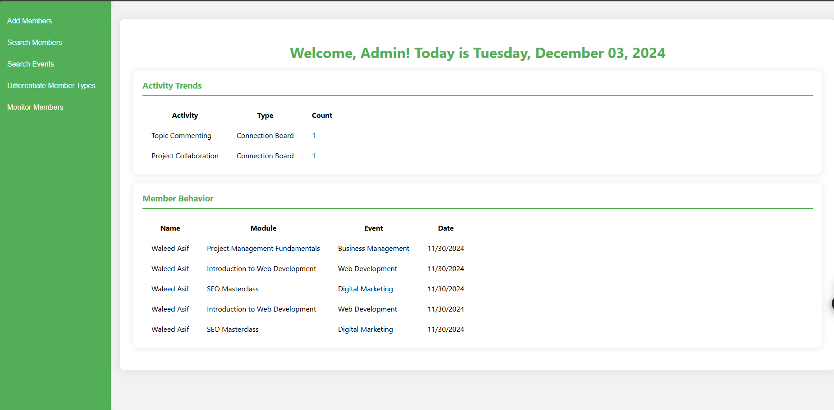

On clicking Add Members button, administrator would be able to see the requests of the new members that need to be added.

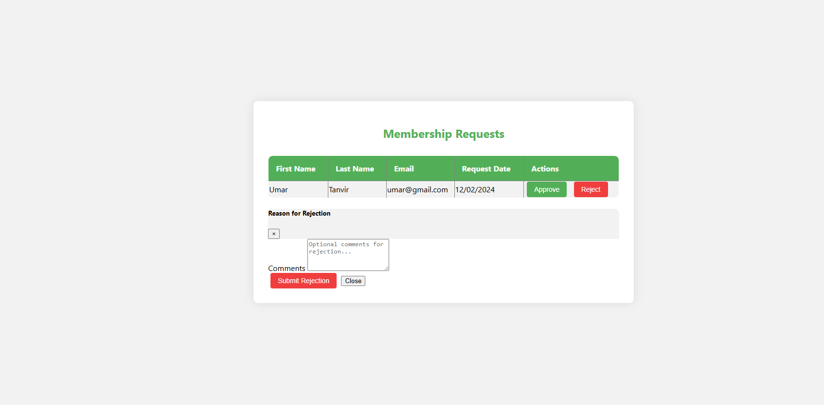

Administrators can now accept or reject the request that has been submitted. For the rejection, administrators can provide the reason for the rejection. If accepted, new members can access the member dashboard.

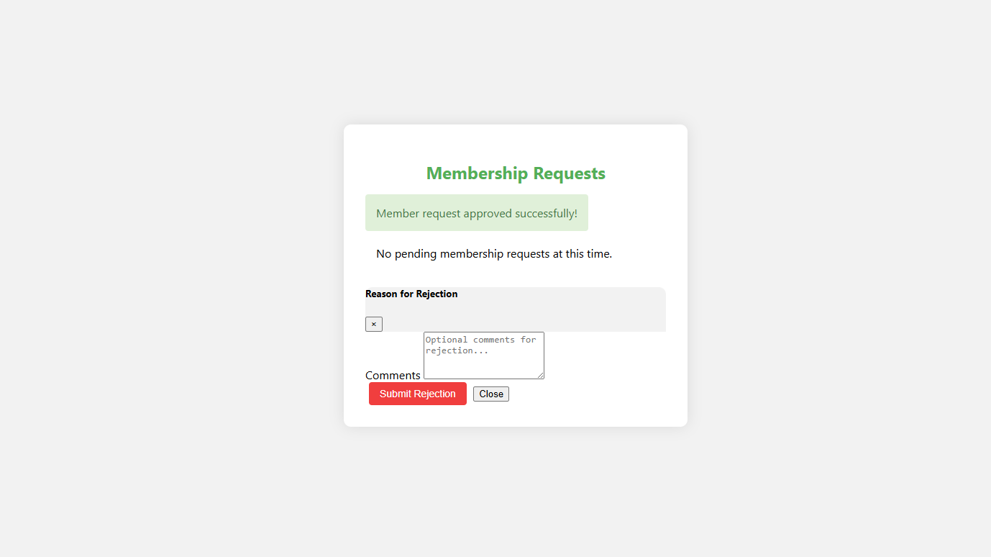

If there are no pending member requests in the database, the administrator is going to be notified that no pending members have requested for the membership.

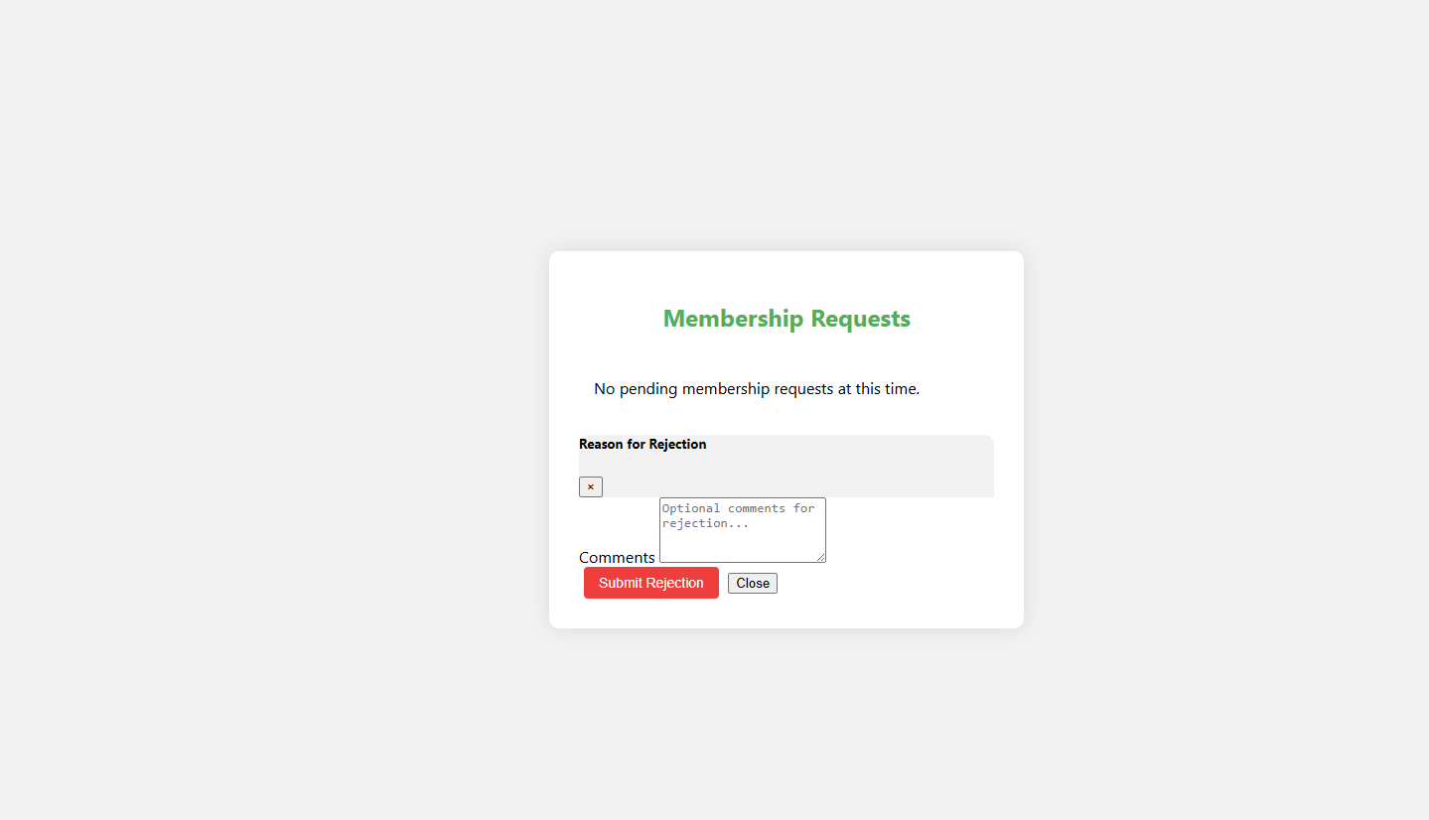

### 3.1.2 User Story 2:

*“As an administrator, I want to search for individual members and non-members to see all the events and visits they’ve made to Together Culture.”*

The administrator would sign in to the system using the credentials. Admin needs to enter email and password for the validation.



If email or password for the administrator is wrong, the administrator would not be able to access the admin dashboard.



If the email and password are correct, the administrator would be able to access the dashboard. The administrator would be able to add the members, search the members, differentiate member types, and monitor new members.



On clicking search members buttons, administrators would be able to see all the members, non-members and events.

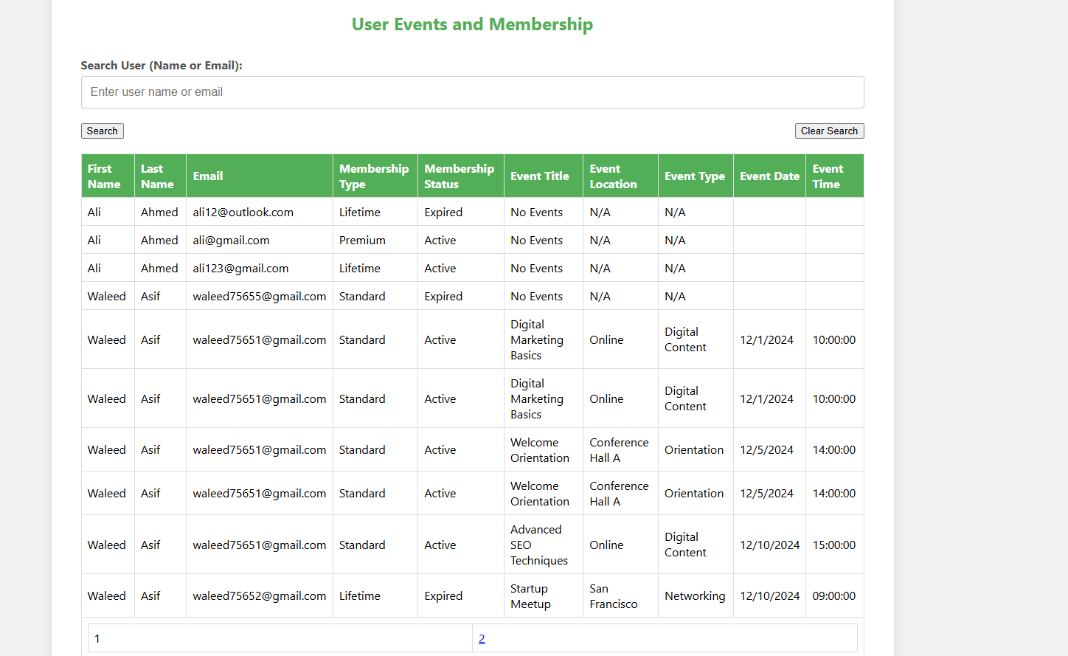

Administrators can now search members and non-members based on their name and email.

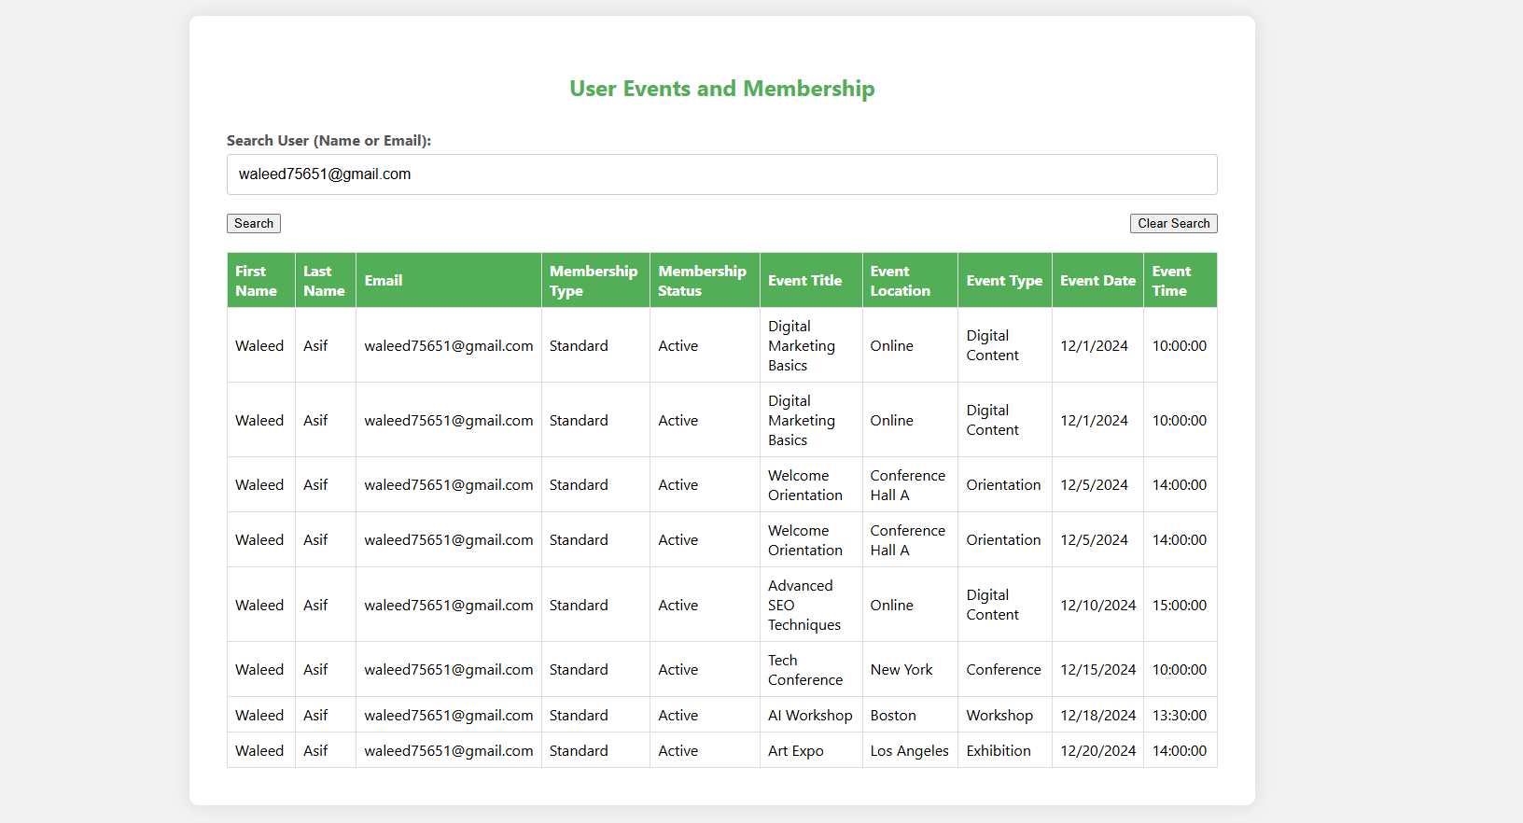

The administrators can also clear the search and search for another member or non-member by clicking clear search button that would clear the current search.

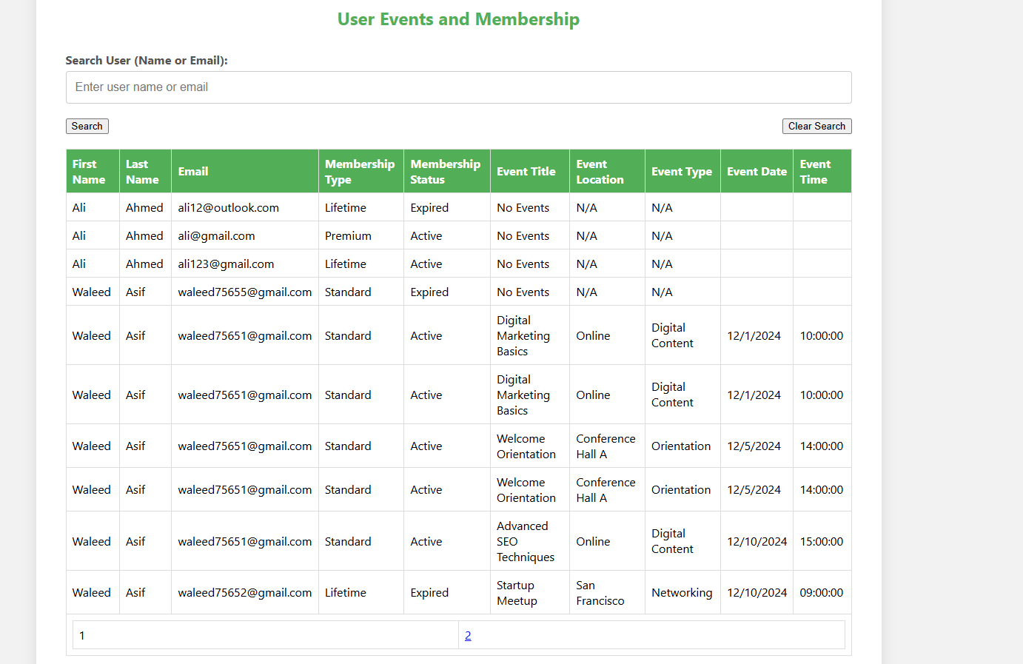

### 3.1.3 User Story 3:

*“As an administrator, I want to search for specific events or time periods to see how many guests attended and identify who those guests were.”*

The administrator would sign in to the system using the credentials. Admin needs to enter email and password for the validation.



If email or password for the administrator is wrong, the administrator would not be able to access the admin dashboard.



If the email and password are correct, the administrator would be able to access the dashboard. The administrator would be able to add the members, search the members, differentiate member types, and monitor new members.



On clicking search events button, administrator would be able to see all the events the attendance and all necessary information that is retrieved from the database.

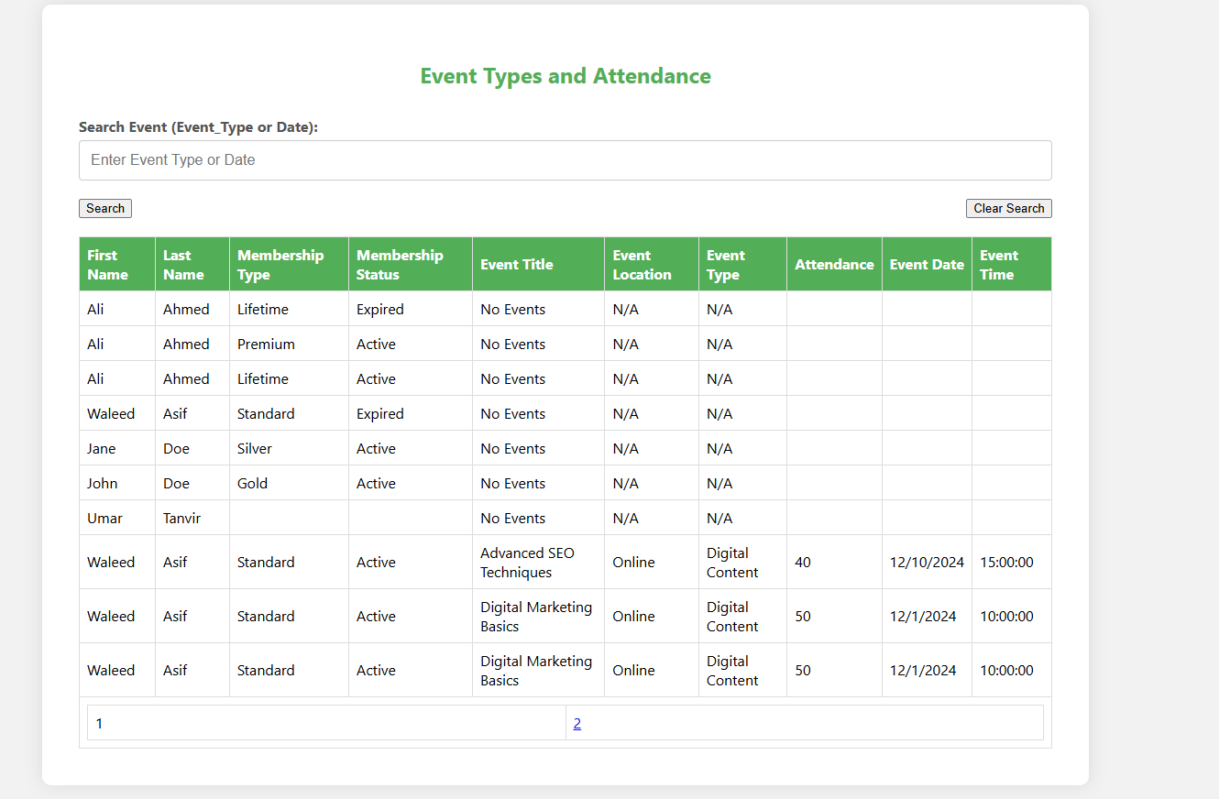

Administrators can search the events by Event Type or Time. On clicking search button the required information would be shown in the table

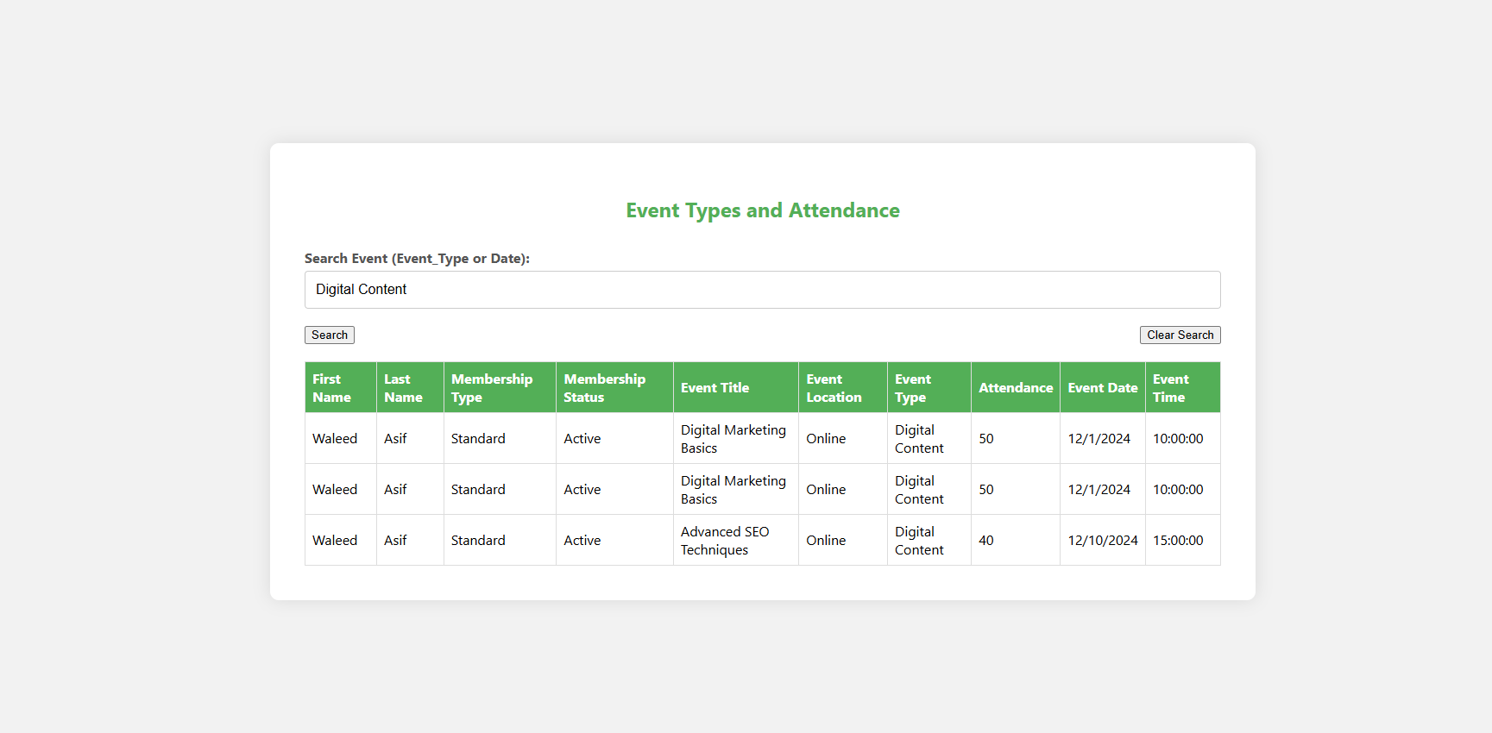

Administrator can clear the search by clicking clear search button. After clicking the button administrator can search another event by date or time.

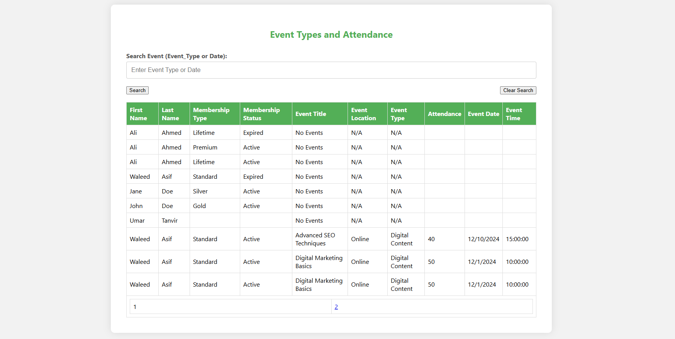

### 3.1.4 User Story 4:

*“As an administrator, I want to create tags that are visible on the dashboard and searchable in a database to identify activity trends and gain insights about member behavior.”*

The administrator would sign in to the system using the credentials. Admin needs to enter email and password for the validation.



If email or password for the administrator is wrong, the administrator would not be able to access the admin dashboard.



If the email and password are correct, the administrator would be able to access the dashboard. The administrator would be able to add the members, search the members, differentiate member types, and monitor new members.



Activity trends and Member Behavior are displayed to the admin on the dashboard. Admin can now see the trends and member behavior individually and manage it.

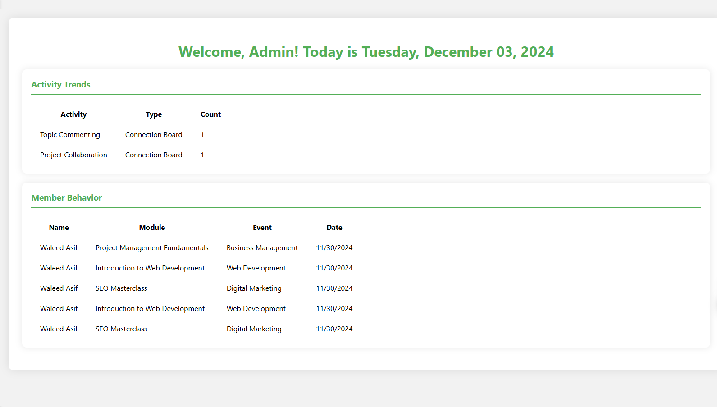

### 3.1.5 User Story 5:

*“As an administrator, I want to differentiate between membership types to manage them effectively.”*

The administrator would sign in to the system using the credentials. Admin needs to enter email and password for the validation.



If email or password for the administrator is wrong, the administrator would not be able to access the admin dashboard.



If the email and password are correct, the administrator would be able to access the dashboard. The administrator would be able to add the members, search the members, differentiate member types, and monitor new members.



On clicking Differentiate Member Types button, administrator would be able to see all the members with the necessary information.

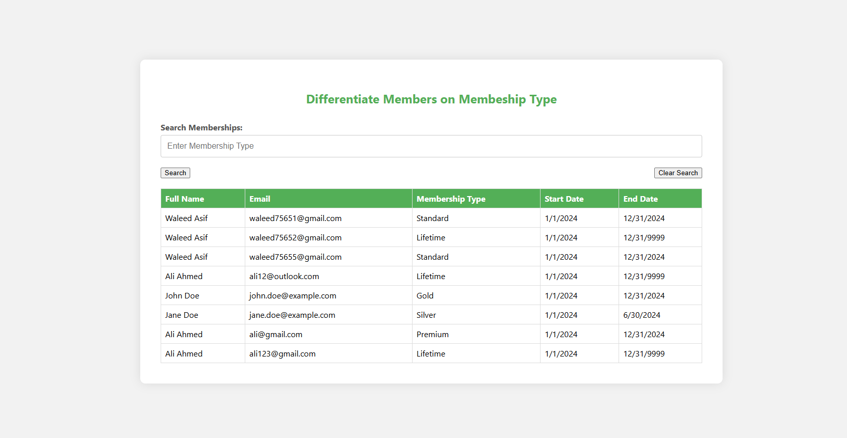

Administrator can now search members based on their membership type. After clicking on search button administrator can see all the members with that specific searched type to manage them effectively.

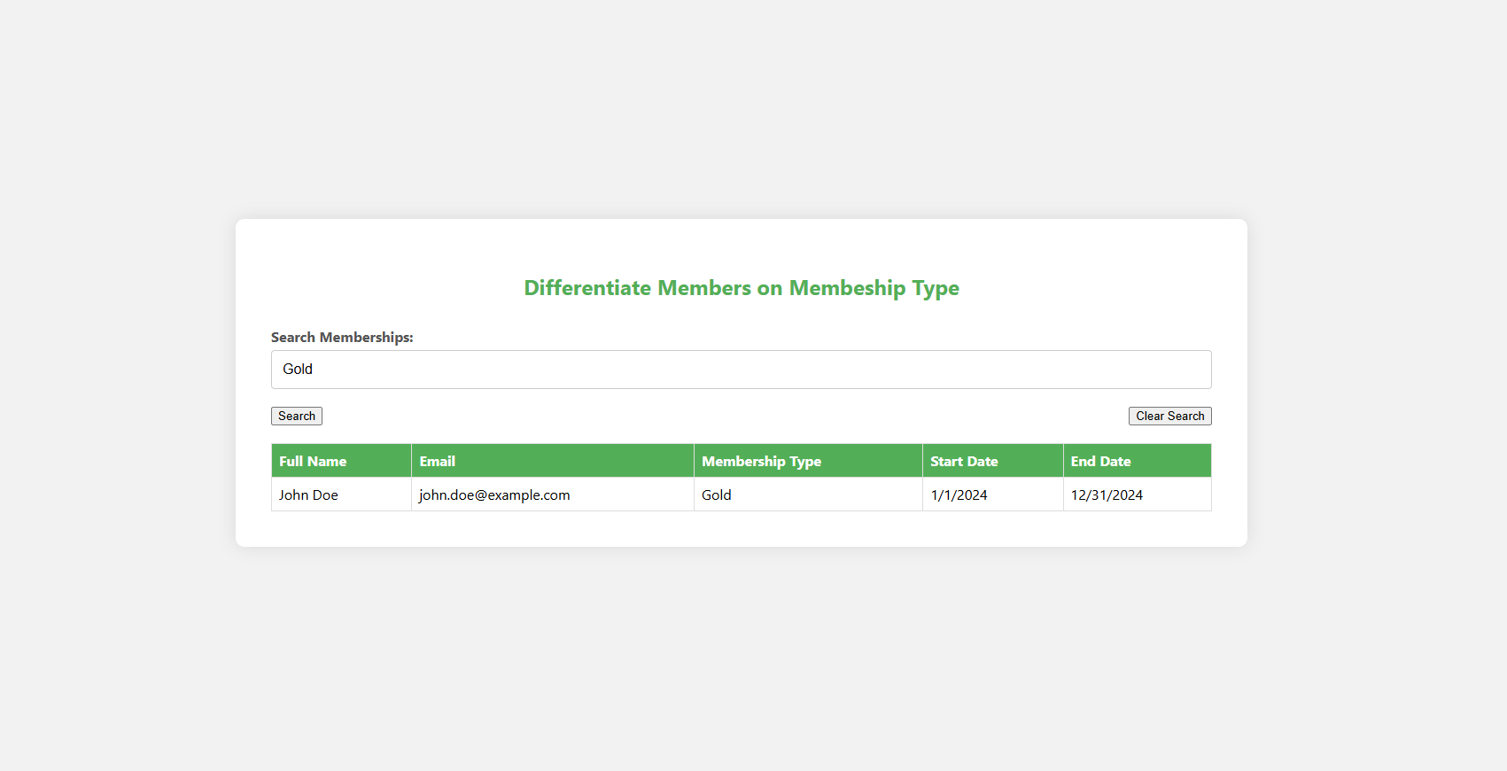

On clicking clear search button, the current search would be cleared, and the administrator would be able search members on their membership types again.

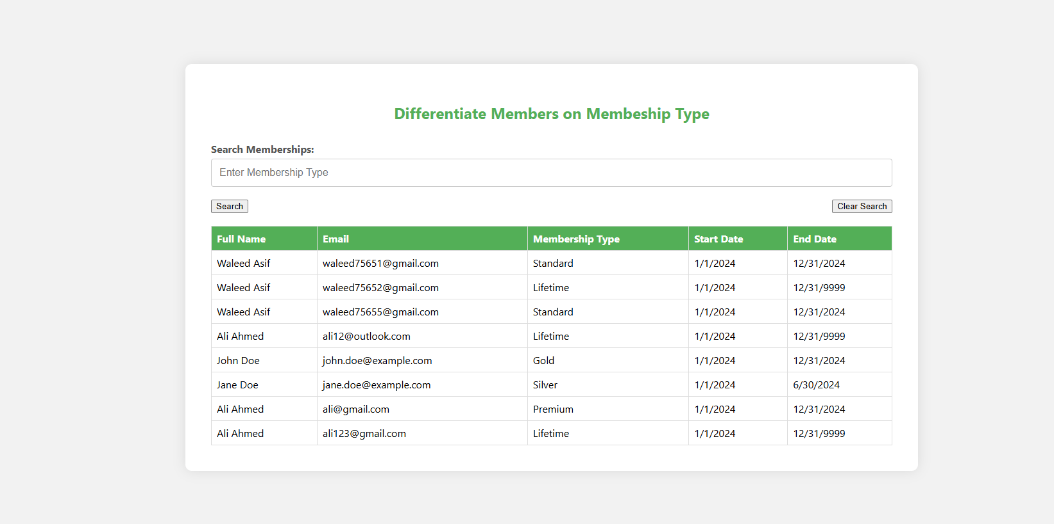

### 3.1.6 User Story 6:

*“As an administrator, I want to monitor new members joining and progressing through our Community Journey to analyses their engagement over time.”*

The administrator would sign in to the system using the credentials. Admin needs to enter email and password for the validation.



If email or password for the administrator is wrong, the administrator would not be able to access the admin dashboard.



If the email and password are correct, the administrator would be able to access the dashboard. The administrator would be able to add the members, search the members, differentiate member types, and monitor new members.



On clicking Monitor Members button, administrator would be redirected to the table with necessary information to monitor the new members and their engagement over time. The engagement can be identified by engagement score of each member.

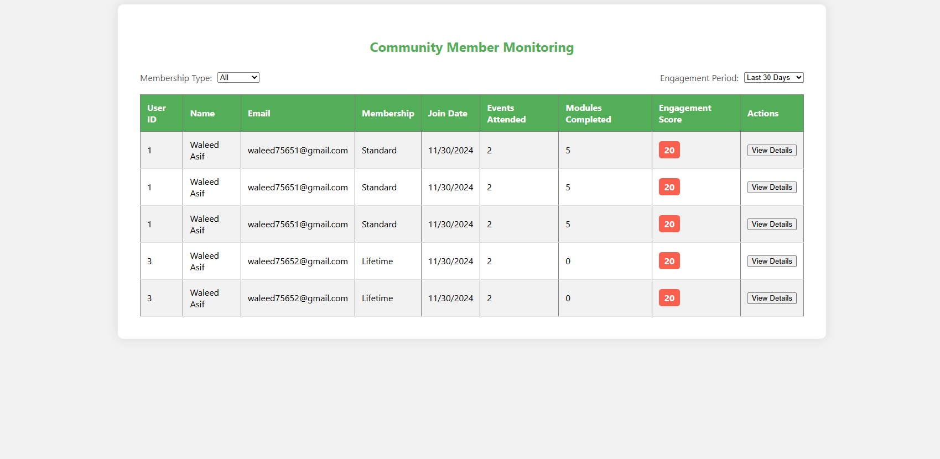

Admin can filter the members on their membership types to filter them out.

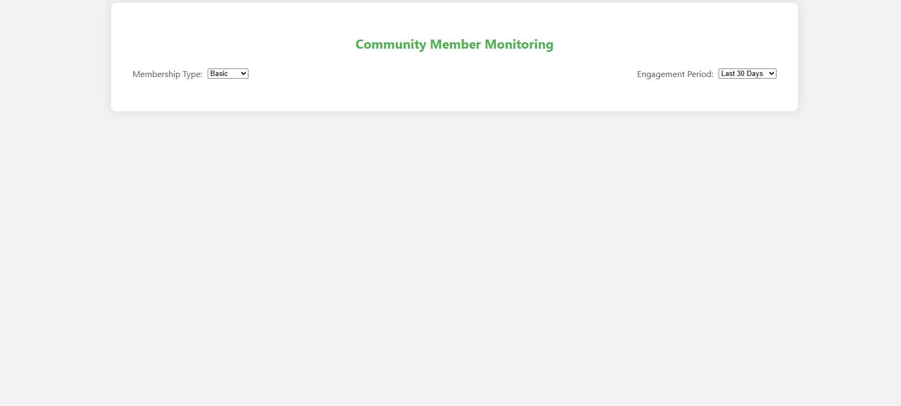

Admins can also filter the members based on the engagement period for last 30, 60 and 180 days from the dropdown menu.

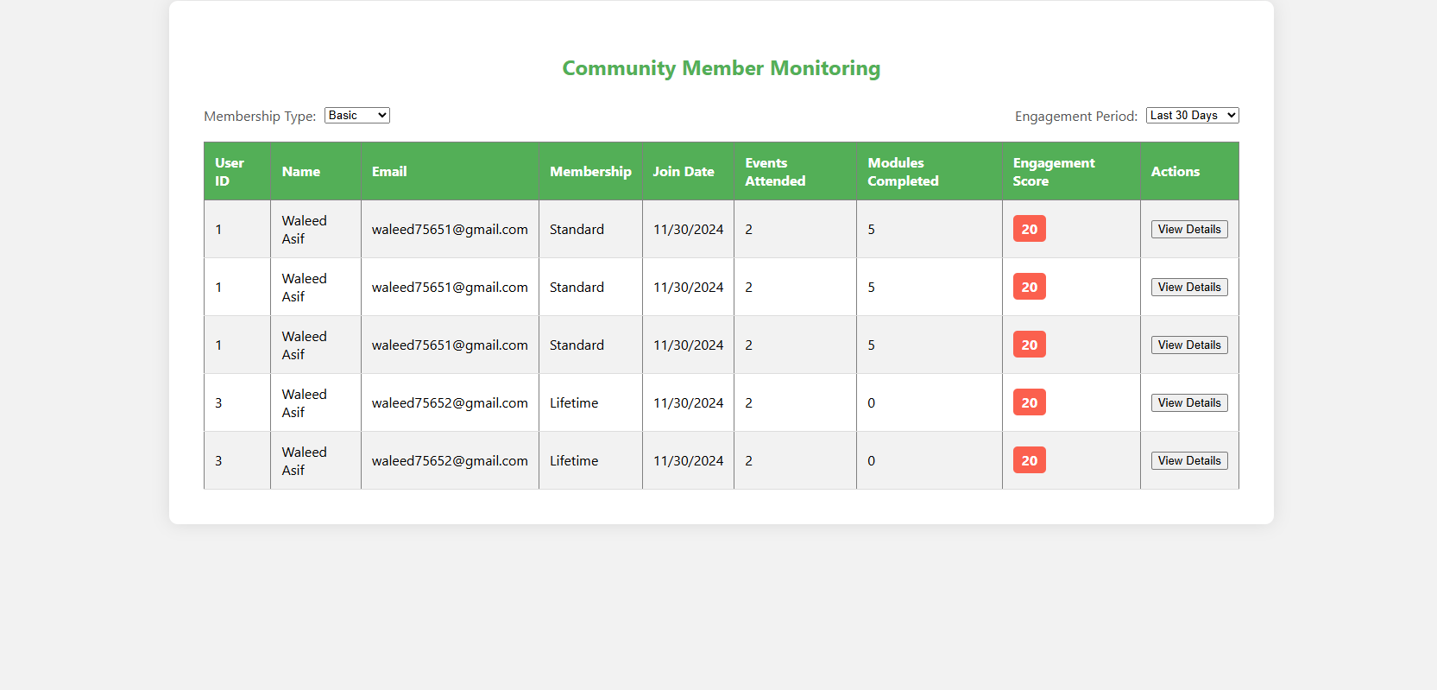

Admin can also view the details of each new member to get their information and manage them effectively.

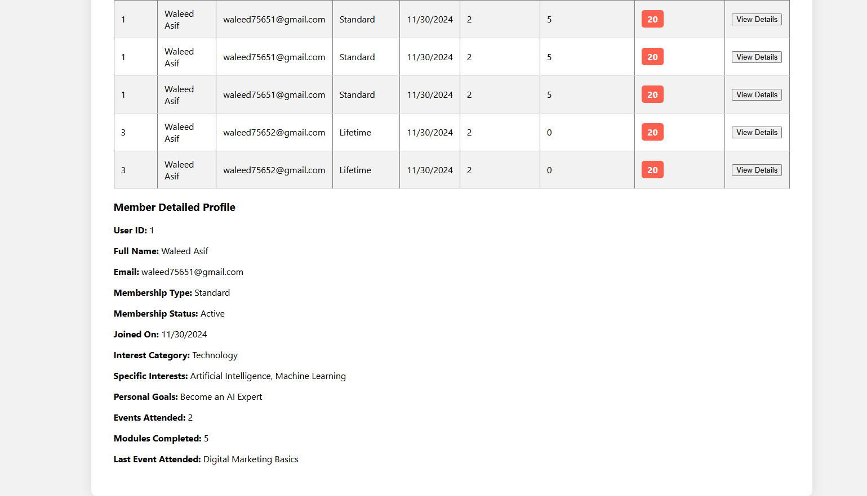

### 3.1.7 User Story 7:

*“As an administrator, I want to authorize members who express interest in joining by creating a profile to ensure they meet our community standards.”*

The administrator would sign in to the system using the credentials. Admin needs to enter email and password for the validation.



If email or password for the administrator is wrong, the administrator would not be able to access the admin dashboard.



If the email and password are correct, the administrator would be able to access the dashboard. The administrator would be able to add the members, search the members, differentiate member types, and monitor new members.



On clicking Add Members button, administrator would be able to see the requests of the new members that need to be added.



Administrators can now accept or reject the request that has been submitted. For the rejection, administrators can provide the reason for the rejection. If accepted, new members can access the member dashboard.



If there are no pending member requests in the database, the administrator are going to be notified that no pending members have requested for the membership.



### 3.1.8 User Story 8:

*“As a member, I want to view and book the full series of digital content modules so I can enhance my learning and involvement.”*

New User can sign up to the system, by providing the necessary details i.e first name, last name, email and password.

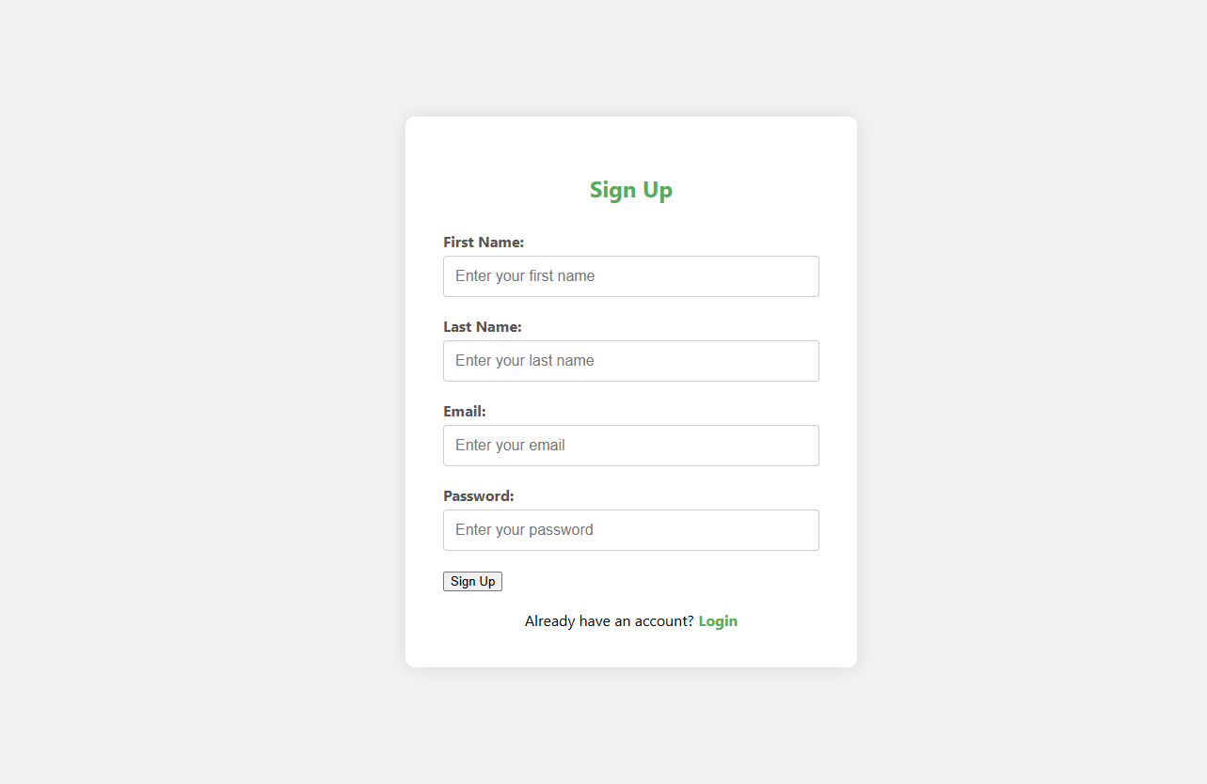

If any of the fields is missing the user is notified to enter the entire information in order to register.

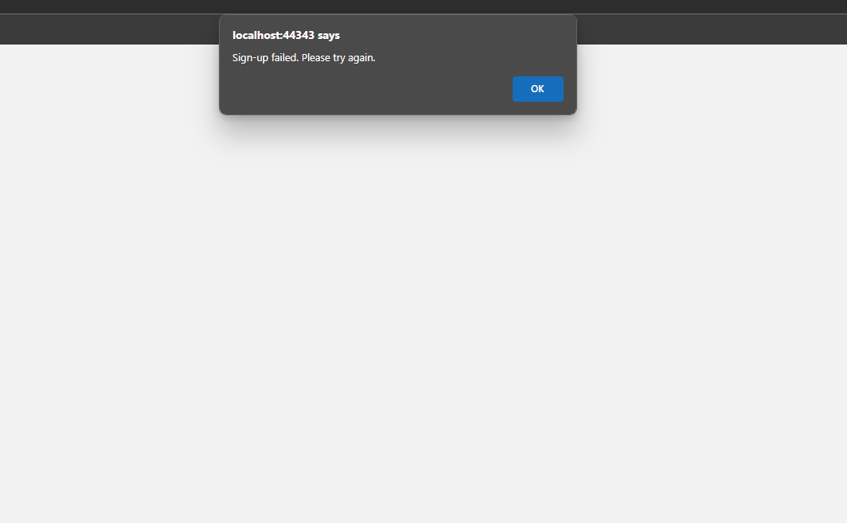

If the signup is successful, the user be redirected to the login page. The member approval request is also sent to the admin

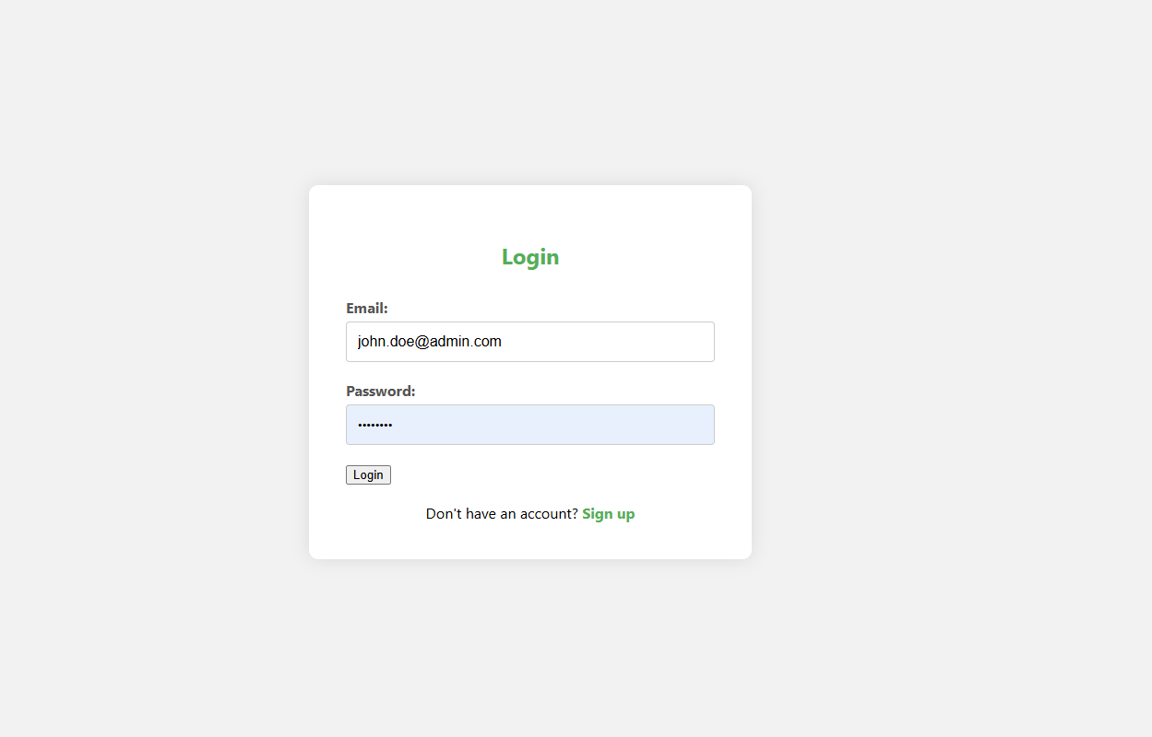

If the user tries to sign in before the admin approval or rejection, the user is notified that the request is sent to the admin wait for the response.

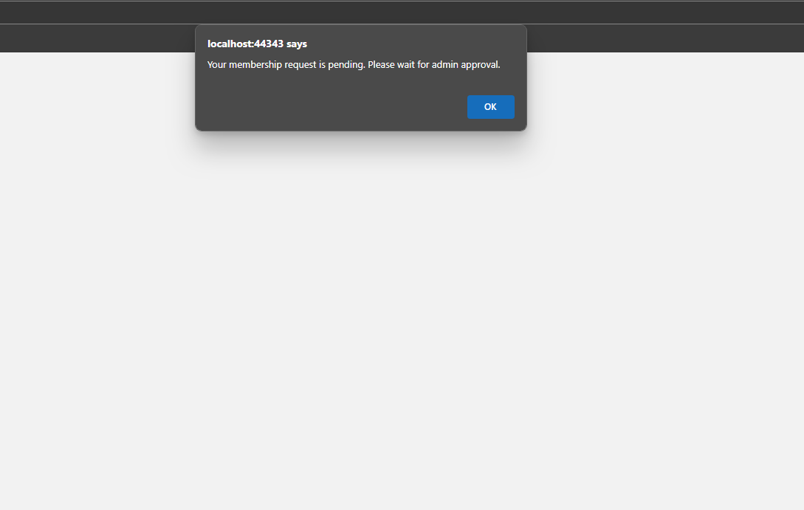

If the admin, has accepted the request, user on login would be able to see the member dashboard where the member can view digital content, book digital content, access orientation information and view benefits.

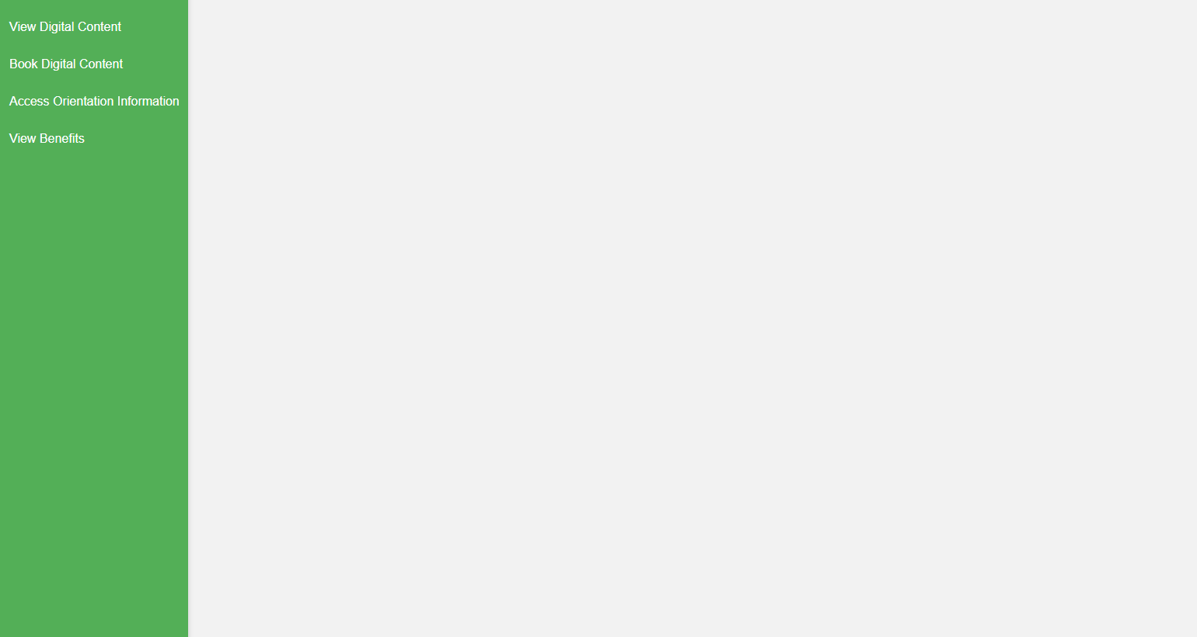

On clicking view digital content button, members would be able to view full series of digital content modules.

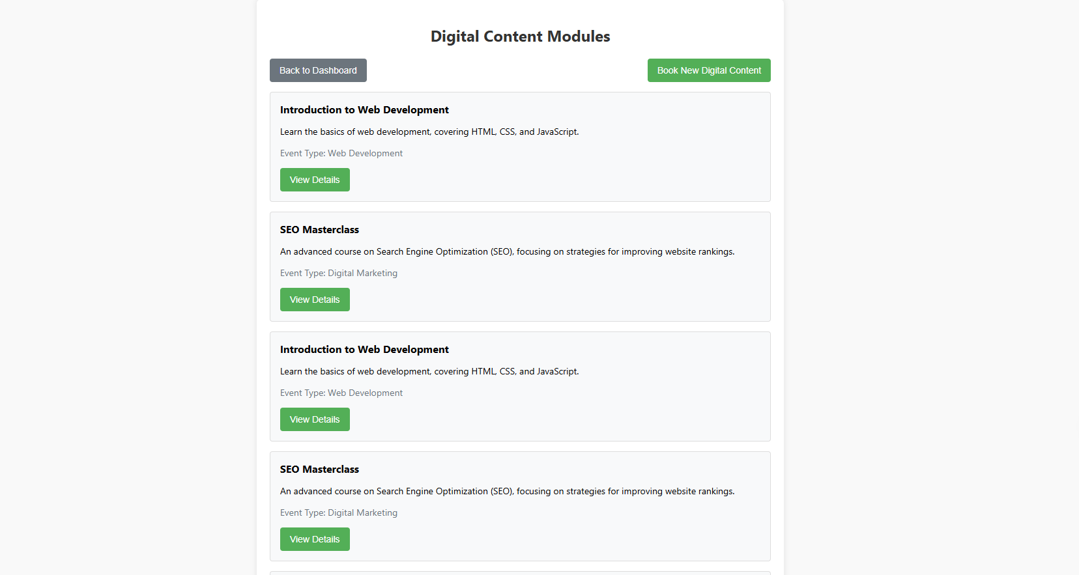

If the member wants to book the available content, he/she can click on book new digital content button. A series of content would be displayed in a table.

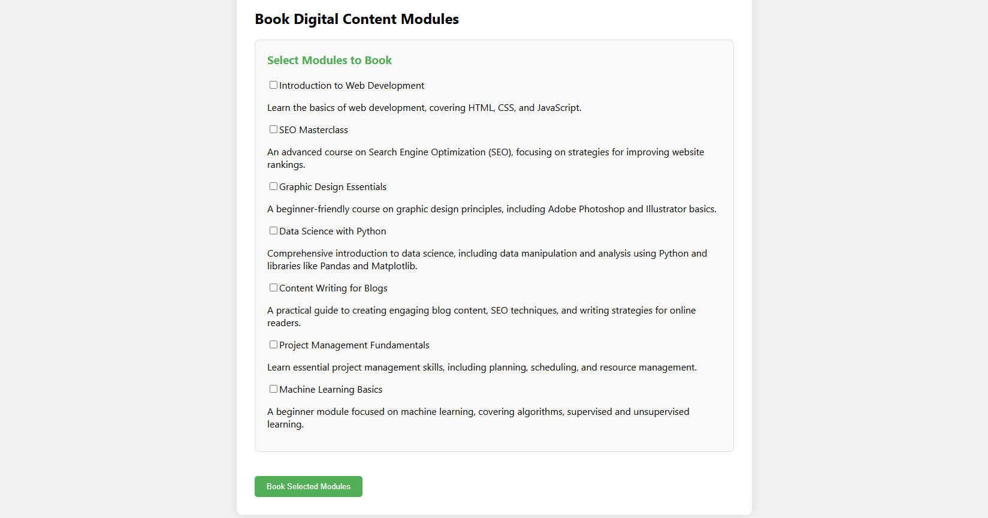

Member can select multiple digital content modules. After selecting the modules that he/she wants to book. Book selected modules button needs to be clicked.

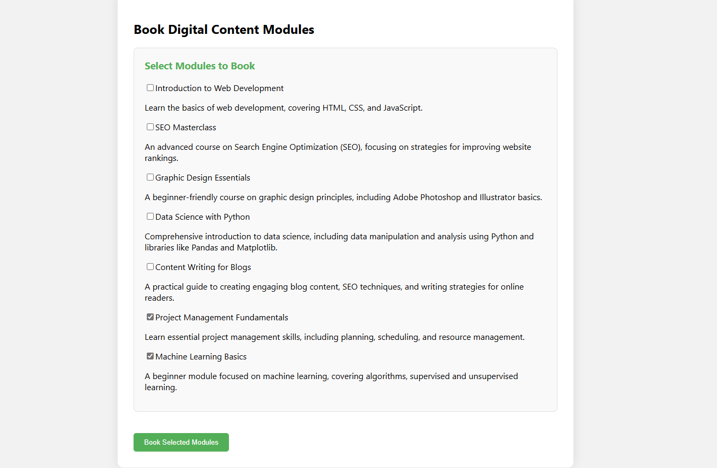

If the selected modules are not booked earlier, the member is going to be notified that the Modules are booked successfully.

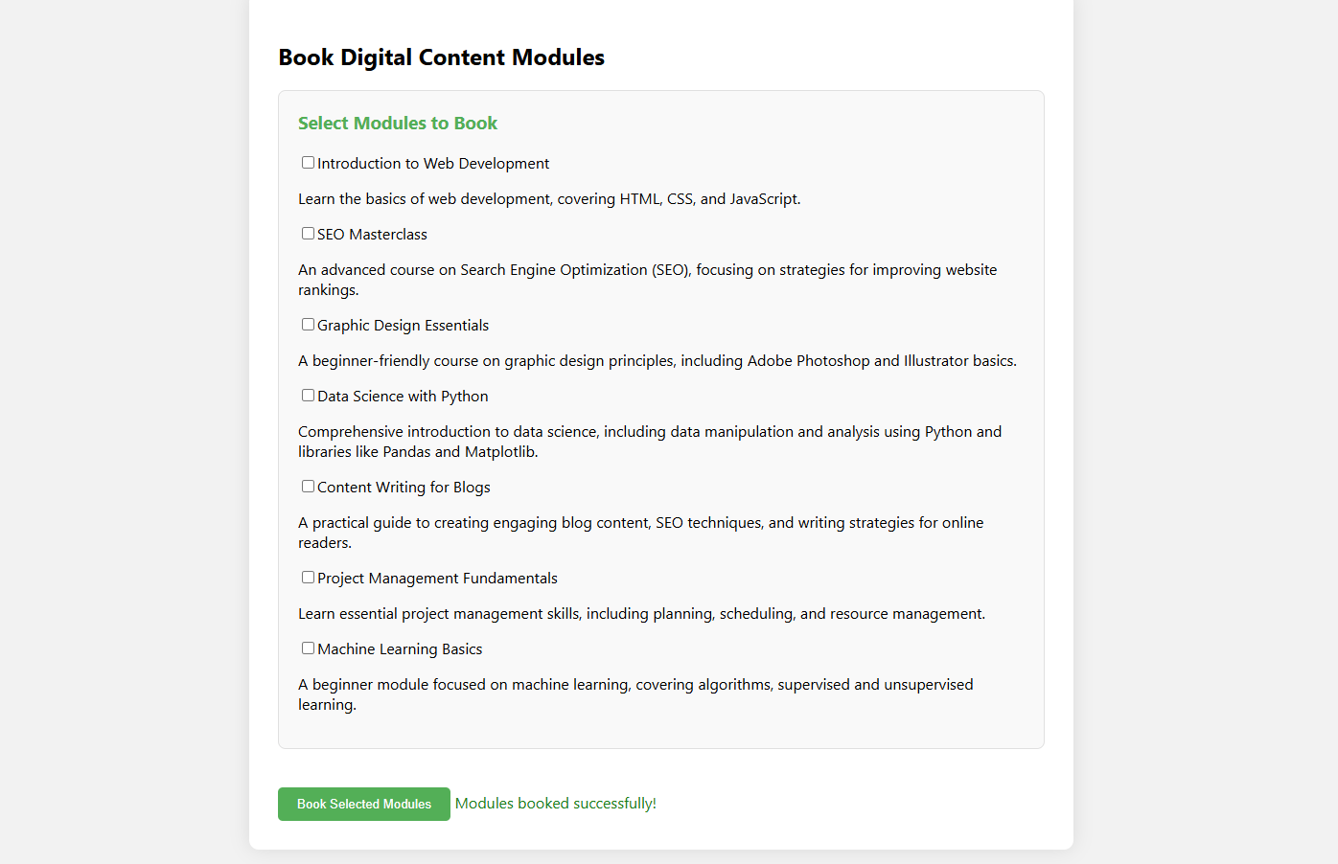

On clicking back to dashboard, member is redirected to the member dashboard with the same options.

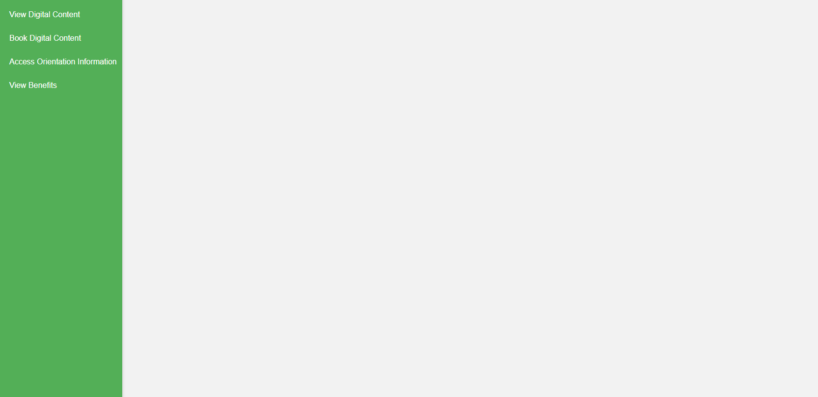

### 3.1.9 User Story 9:

*“As a member, I want to see a dashboard view of the benefits I am using and those I have not utilized, helping me understand the value of my membership.”*

New User can sign up to the system, by providing the necessary details i.e first name, last name, email and password.



If any of the fields is missing the user is notified to enter the entire information in order to register.



If the signup is successful, the user be redirected to the login page. The member approval request is also sent to the admin



If the user tries to sign in before the admin approval or rejection, the user is notified that the request is sent to the admin wait for the response



If the admin, has accepted the request, user on login would be able to see the member dashboard where the member can view digital content, book digital content, access orientation information and view benefits



On Clicking view benefits button, member is able to view the membership type, and the benefits of the membership that are not currently utilized by him/her

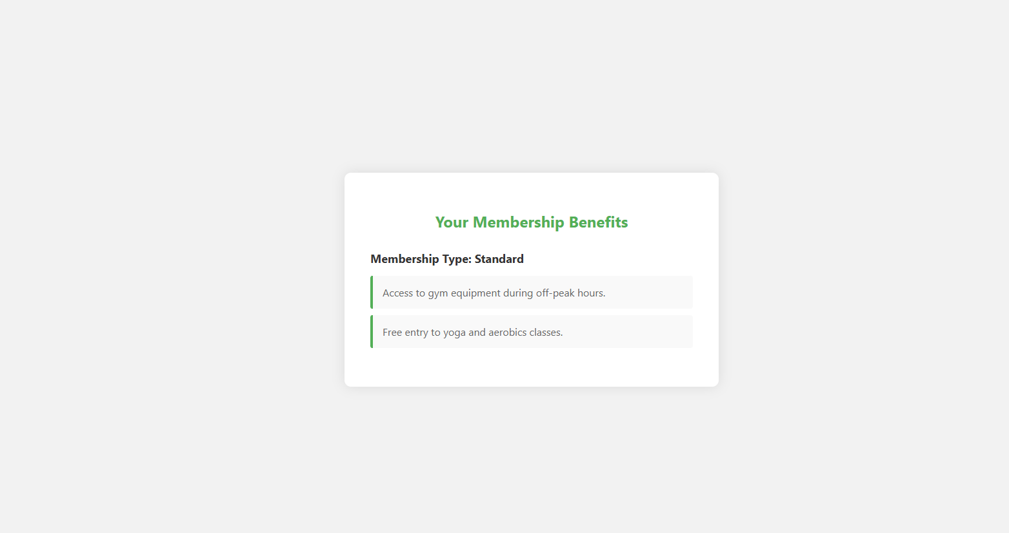

### 3.1.10 User Story 10:

*“As a member, I want to access the information I provided about my interests and intentions during my orientation to stay aligned with my goals.”*

New User can sign up to the system, by providing the necessary details i.e. first name, last name, email and password.



If any of the fields is missing the user is notified to enter the entire information in order to register.



If the signup is successful, the user be redirected to the login page. The member approval request is also sent to the admin.



If the user tries to sign in before the admin approval or rejection, the user is notified that the request is sent to the admin wait for the response.



If the admin, has accepted the request, user on login would be able to see the member dashboard where the member can view digital content, book digital content, access orientation information and view benefits



On Clicking access orientation information, the member would be able to see their interest information. Save and modify it.

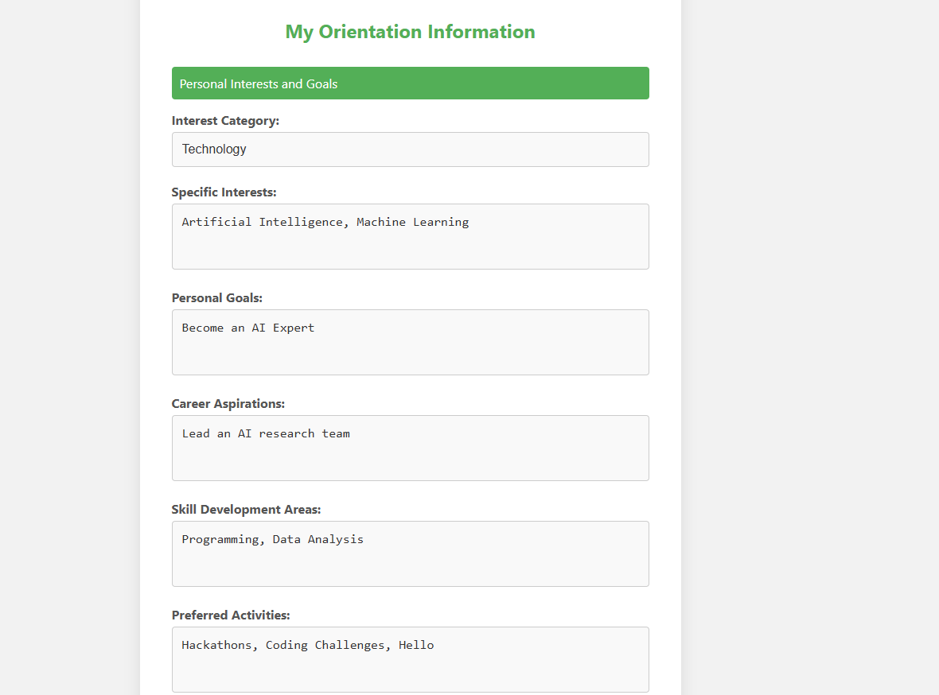

After clicking edit information button the information can be edited by the member.

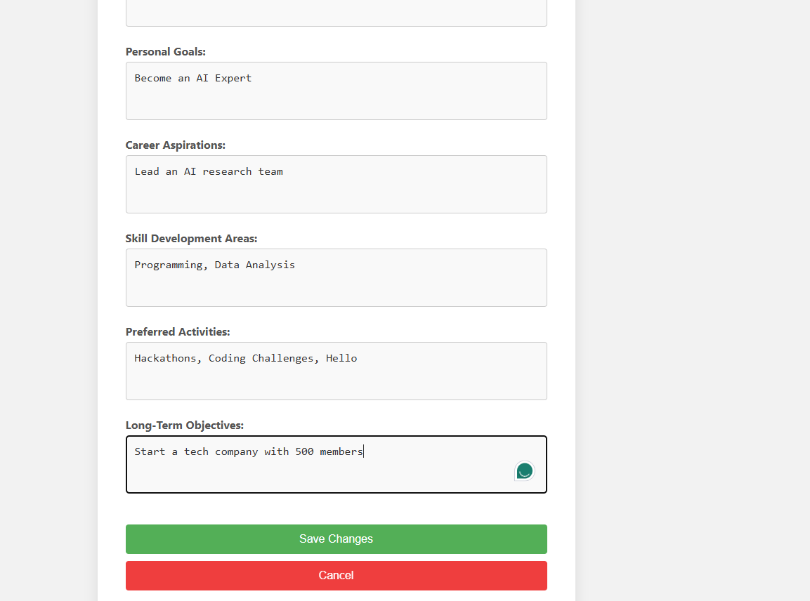

After making changes, save changes button must be clicked that would make sure that the edited information is saved successfully, and the member would be notified. The last date of the last updated interest would be updated and shown to the member.

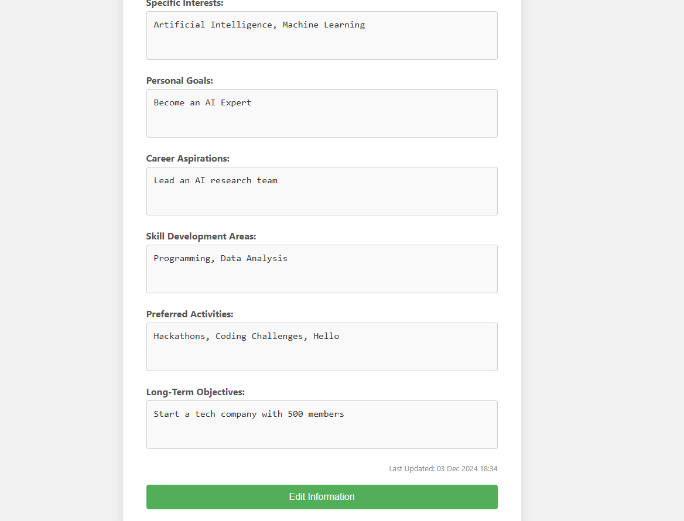

### 3.1.11 User Story 11:

*“As a user, I want to log into a password-protected members-only area to securely access my account and information.”*

New User can sign up to the system, by providing the necessary details i.e first name, last name, email and password.



If any of the fields is missing the user is notified to enter the entire information in order to register.



If the signup is successful, the user be redirected to the login page. The member approval request is also sent to the admin.



If the user tries to sign in before the admin approval or rejection, the user is notified that the request is sent to the admin wait for the response.



If the admin, has accepted the request, user on login would be able to see the member restricted area only that no one can access making sure that the information is safe and secure.



### 3.1.12 User Story 12:

*“As a user, I want to express my interest in becoming a member by creating a profile that requires administrator approval.”*

New User can sign up to the system, by providing the necessary details i.e first name, last name, email and password.



If any of the fields is missing the user is notified to enter the entire information in order to register.



If the signup is successful, the user be redirected to the login page. The member approval request is also sent to the admin.



If the user tries to sign in before the admin approval or rejection, the user is notified that the request is sent to the admin wait for the response.



If the admin, has accepted the request, user on login would be able to see the member restricted area only that no one can access making sure that the information is safe and secure.



If the request is rejected by the admin, the user would not be able to access the member dashboard.

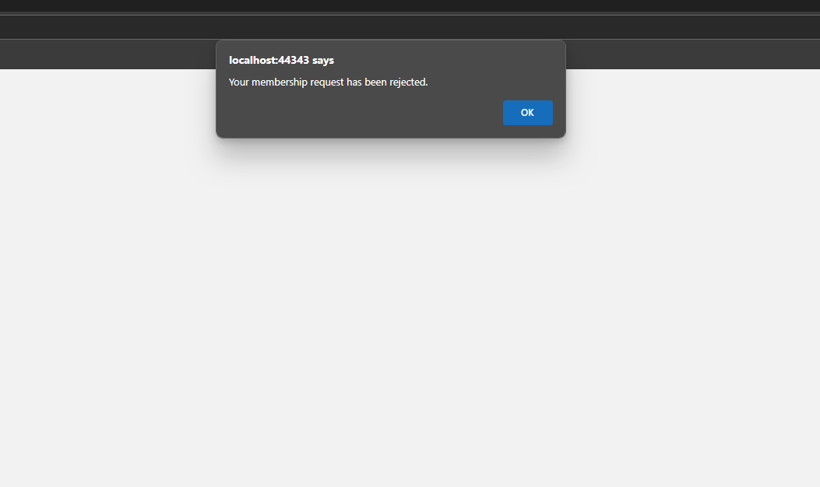

## 3.2 Personal Implementations

## 3.2.1 Front-End Classes

### Signup Form

The author has created various text fields for the user to enter the information. The information entered by the user then goes to the backend. The placeholders and IDs for the respective text boxes are defined.

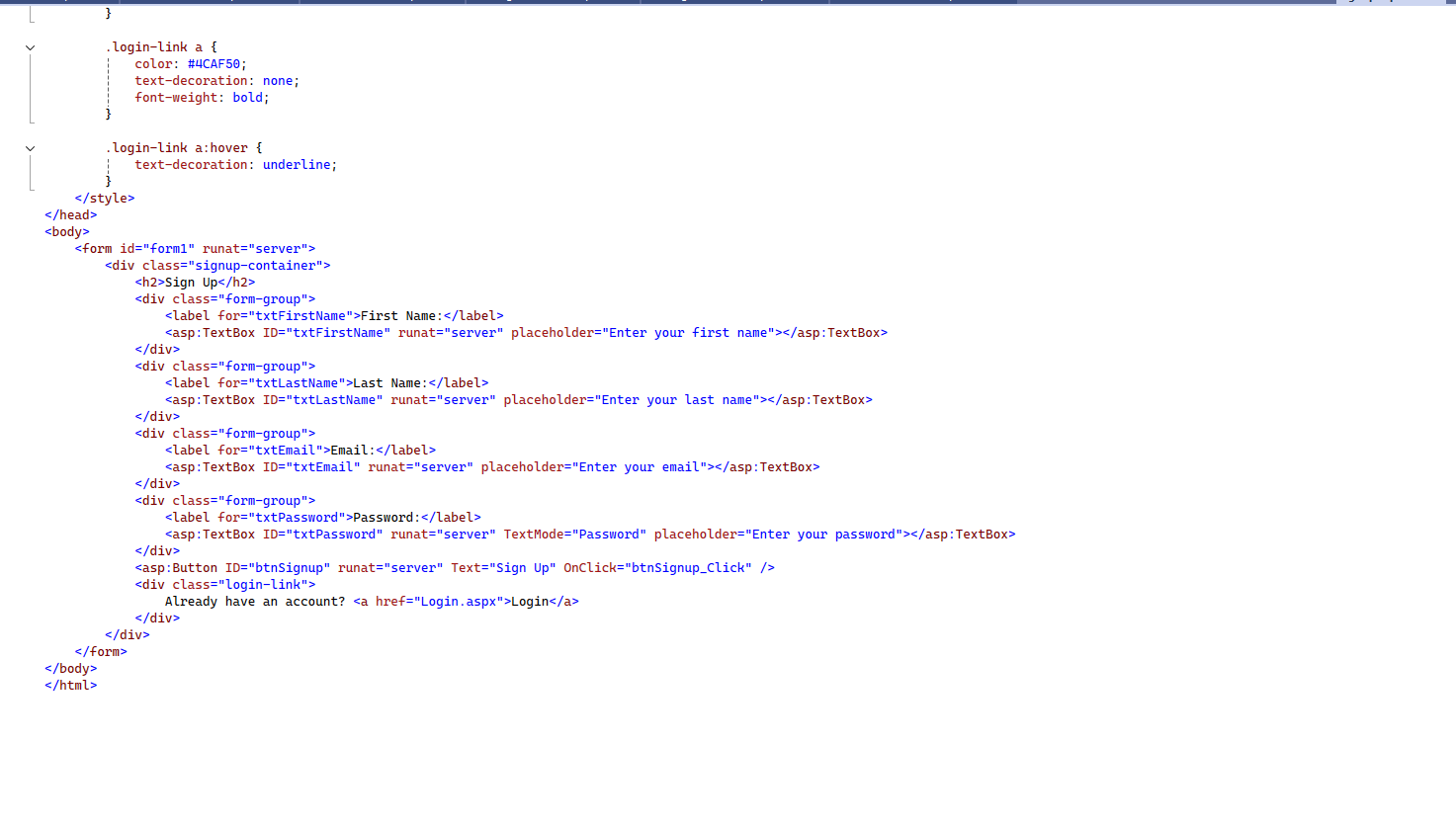

### Login form

The author has implemented various text fields for email and password. Each text field has its own format. The author has created a button that a user would press to login. The entered data from the fields goes to the backend.

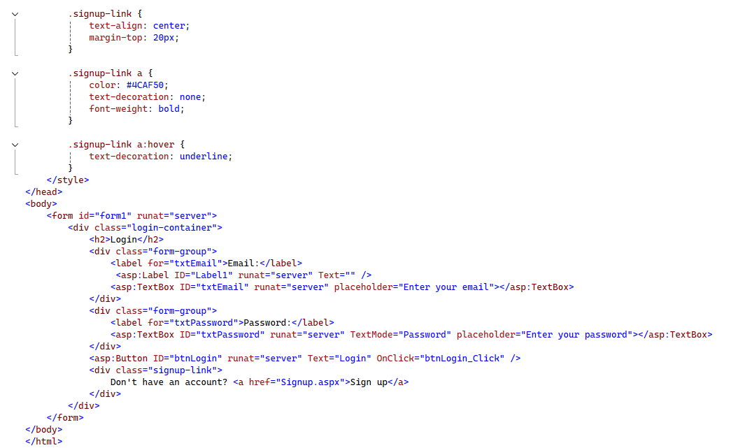

### Member Dashboard

The author has created a member dashboard that has different buttons on the navbar. It allows members to redirect to the page they want. Each button has its own functionality.

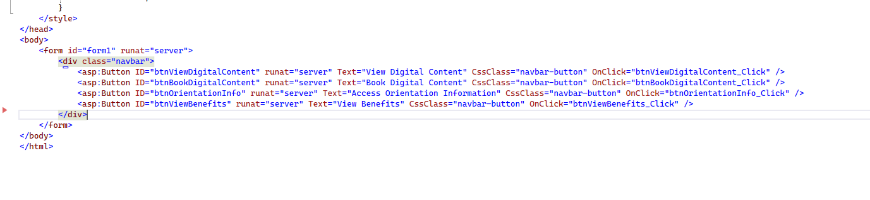

### View Digital Content:

The author has created a view digital content page for the user. It has two buttons; go to dashboard and book digital content for the user to redirect back to the dashboard and book new digital content respectively. It also has a table that shows the digital content information.

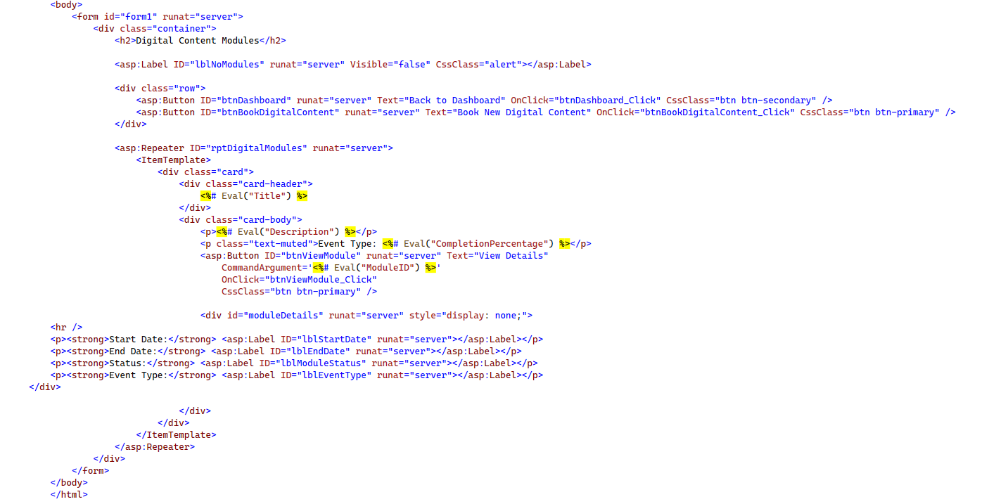

### Book Digital Content:

The author has created a book digital content page that allows the user to select new digital contents and book them. Users can select multiple digital contents together. The page shows a list of new digital content that a user can book.

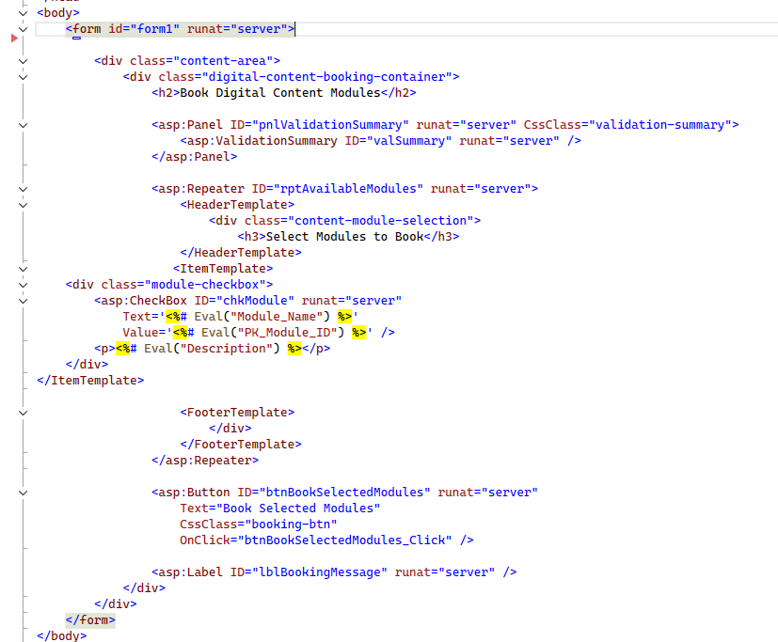

### Access Orientation Information

The author has created a panel to show member their orientation information. It shows different information to the user. It has different text fields and text boxes to show all the information.

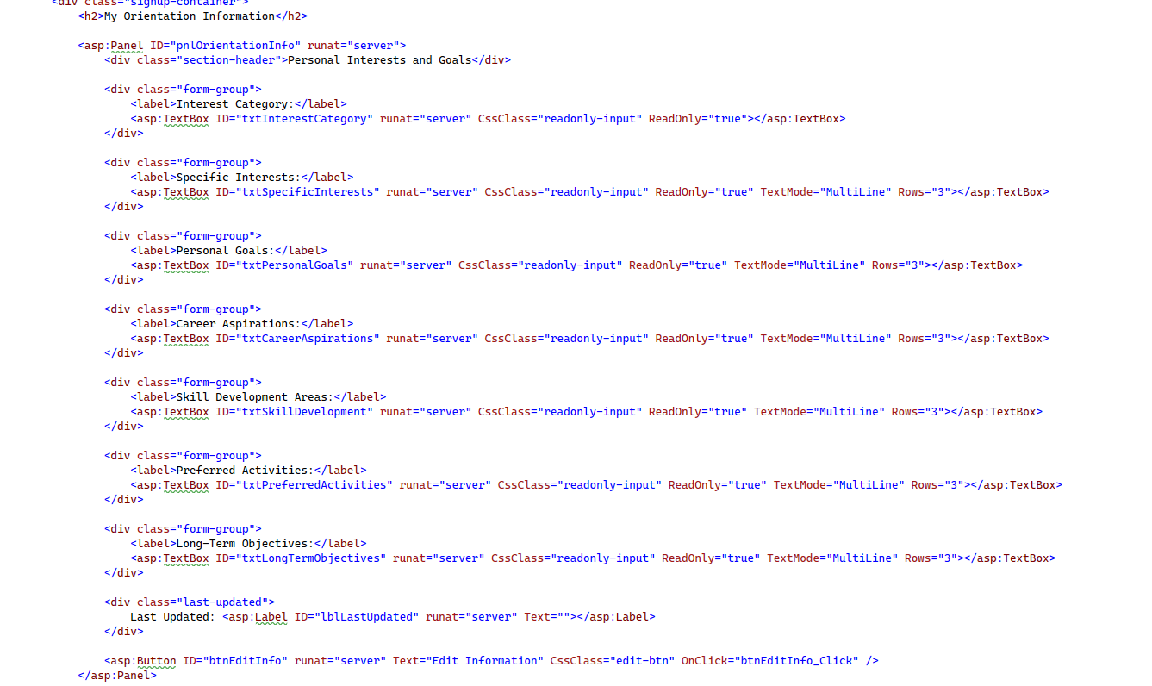

The author has created another panel that enables member to edit their orientation information such as personal interests and goals.

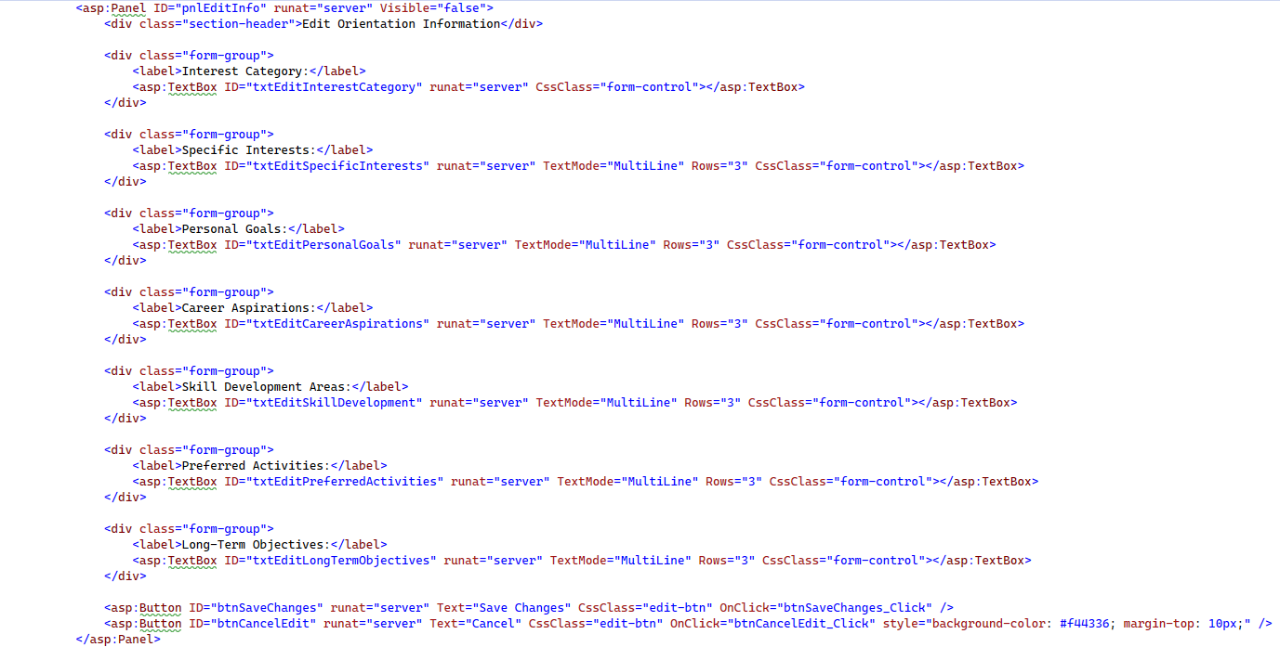

### Membership Benefits

The author has created a form that shows membership benefits to the user. It has different text fields that show membership type and then membership benefits.

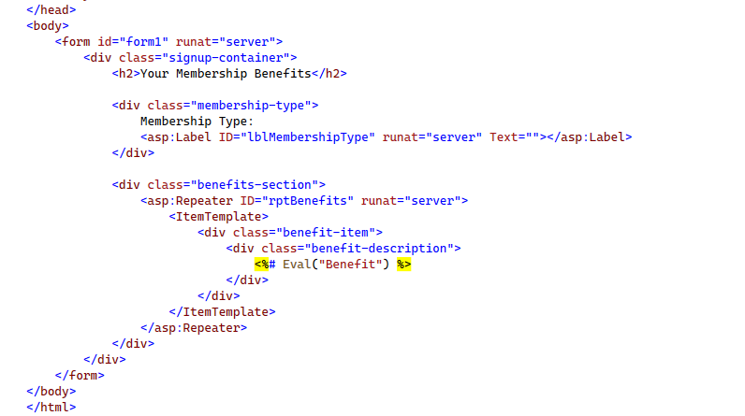

### Admin Dashboard

The author has created an admin dashboard to let admins perform the functionality they want. The admin dashboard has a vertical navbar and different buttons that redirect to different pages. On the dashboard the admin can see the members’ behavior and activity trends.

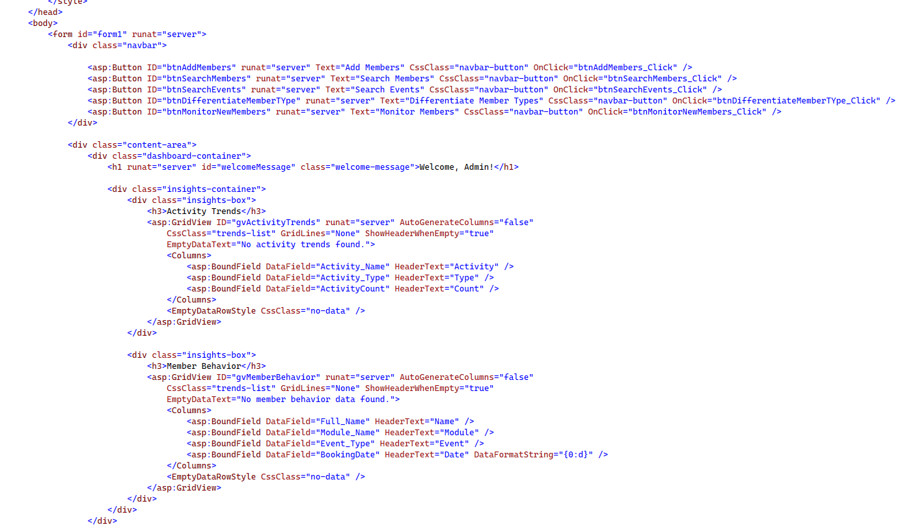

### Member Approval

The author has implemented a member approval class to approve or reject the requests of new members. It has accepted or reject button. While rejecting, admin can input why the user is being rejected but it is optional.

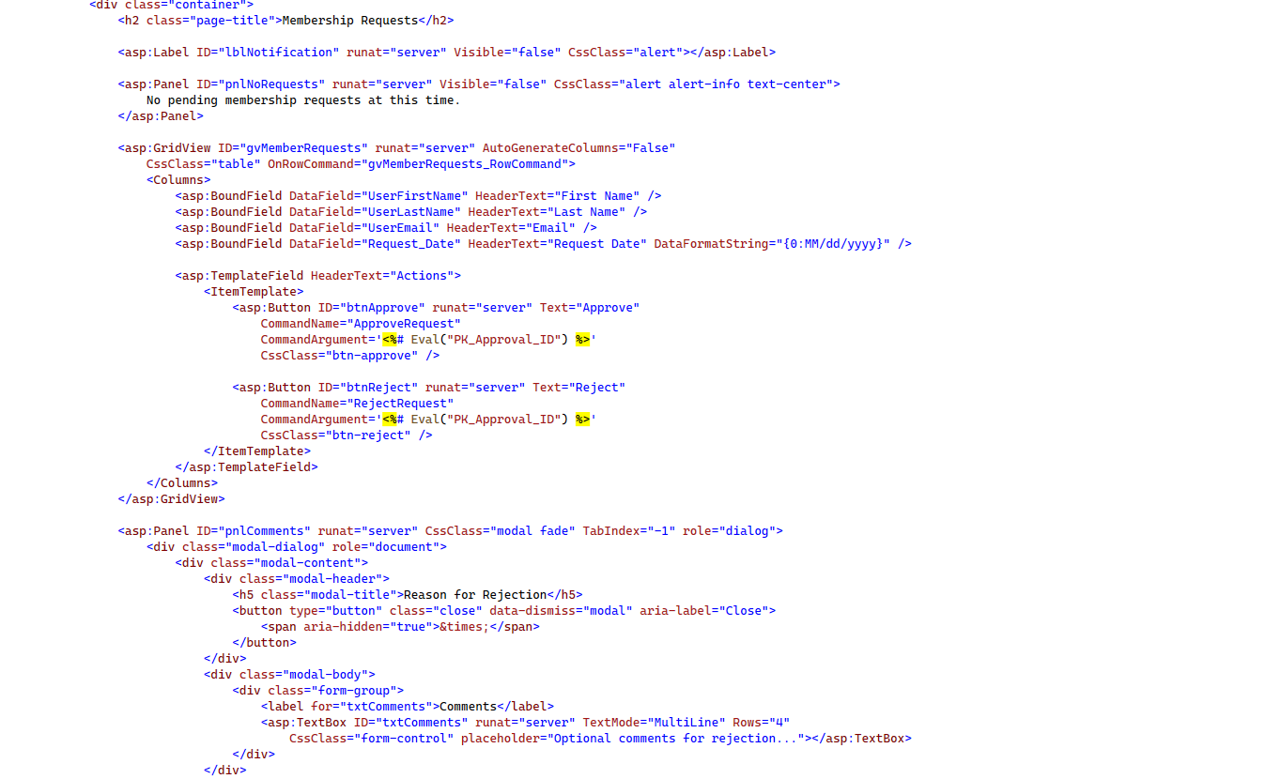

### User Events Search

The author has created a table that shows different columns in a table. There is a search field that enables admin to search members and non members.

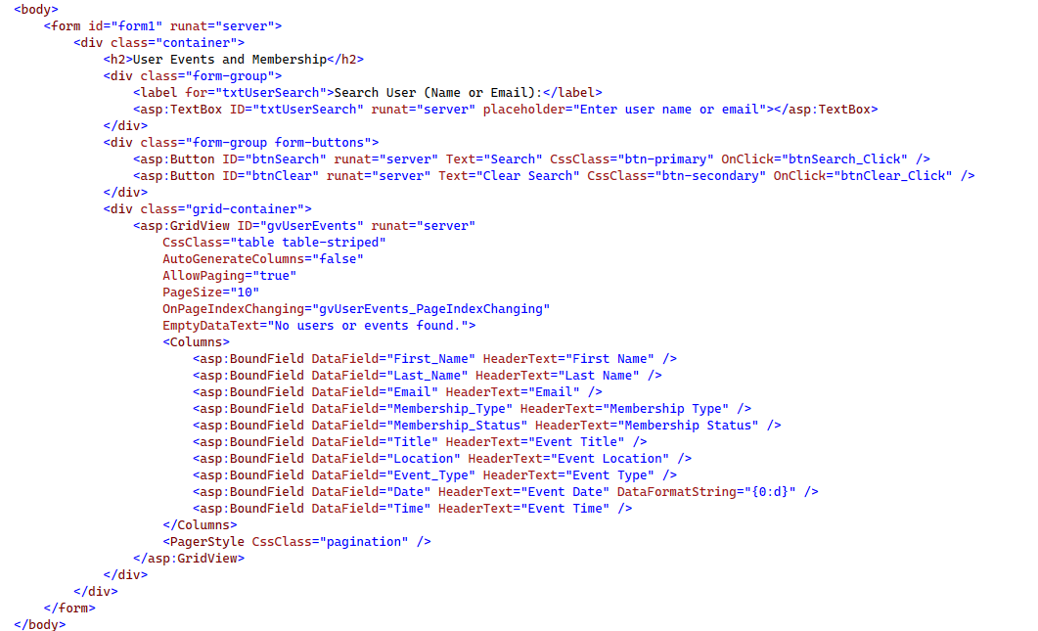

### Specific Search Event

The author has created a table that allows admin to see different information. It contains different columns; all the columns show different information. It allows admin to search members based on different event types.

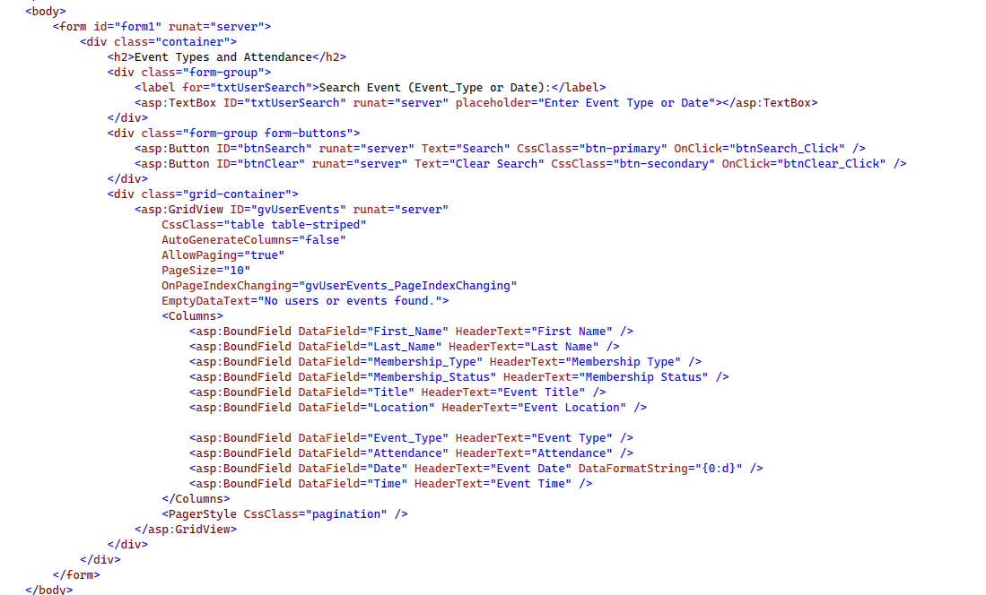

### Search Membership

The author has created a table to show the desired information of the members to the admin. It contains a search button that allows admin to see and manage the members based on their membership type.

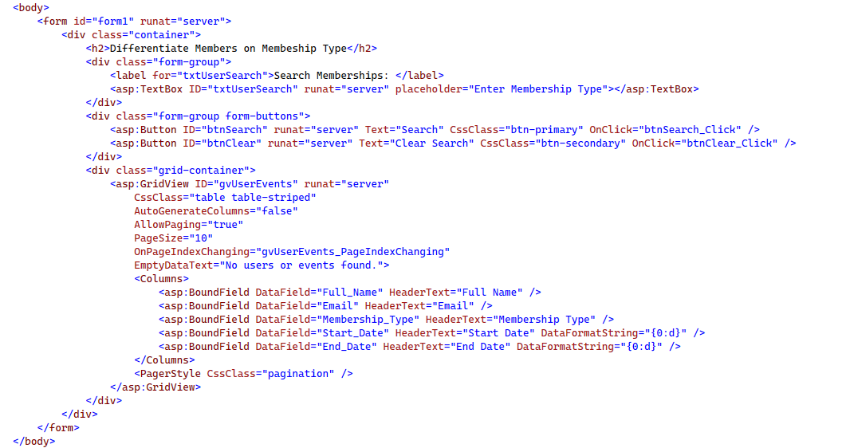

### Monitor Members

The author has created a table that shows all the new members in a table. It also has an option to search for members that joined in the last 30, 60 or 180 days. It allows user to filter members based on their membership types.

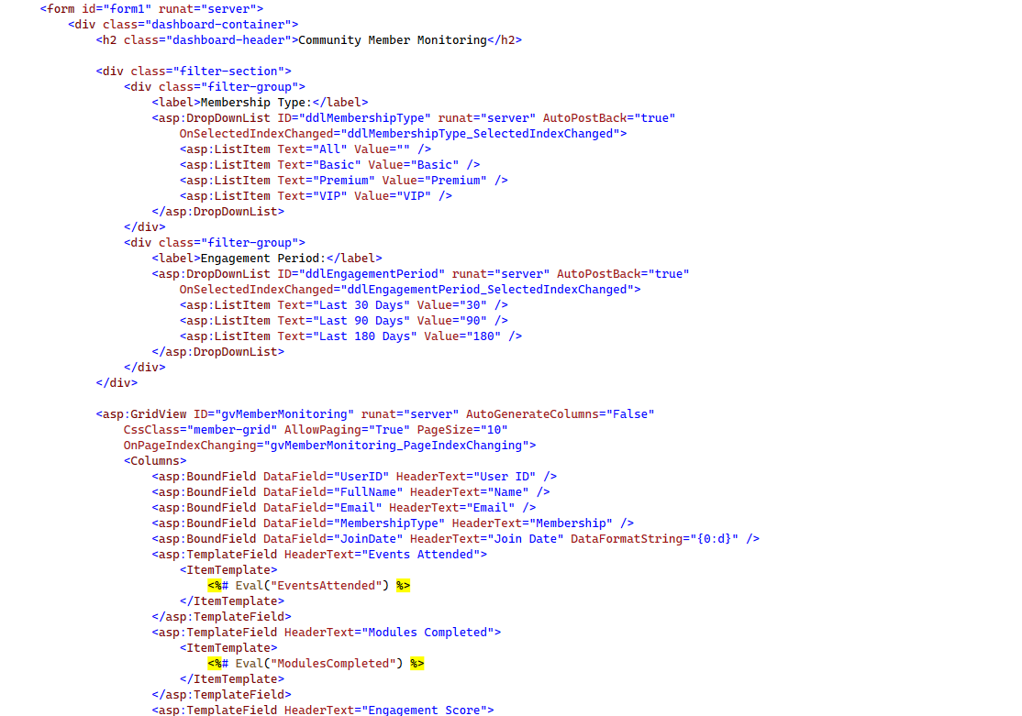

The code also has an engagement score that shows admin the engagement of the current member in the community.

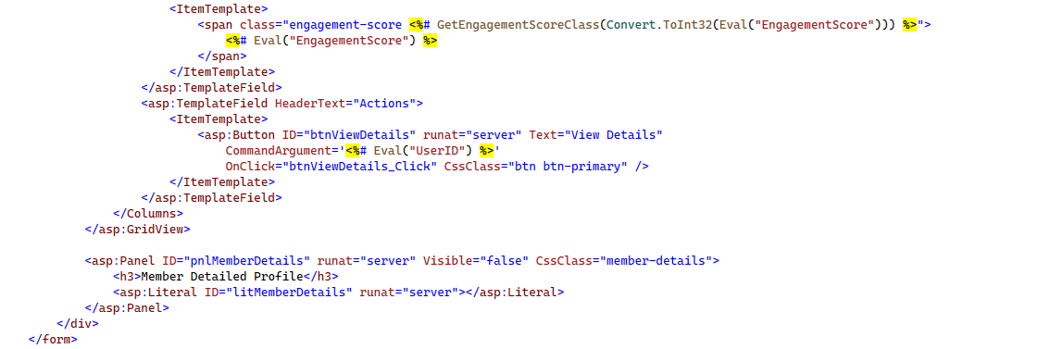

## 3.2.2 Back-end Classes

### Signup

In signup form author has implemented if statements to check if the information entered by the user is correct, if the connection to database is correct and if the query that must be executed is correct.

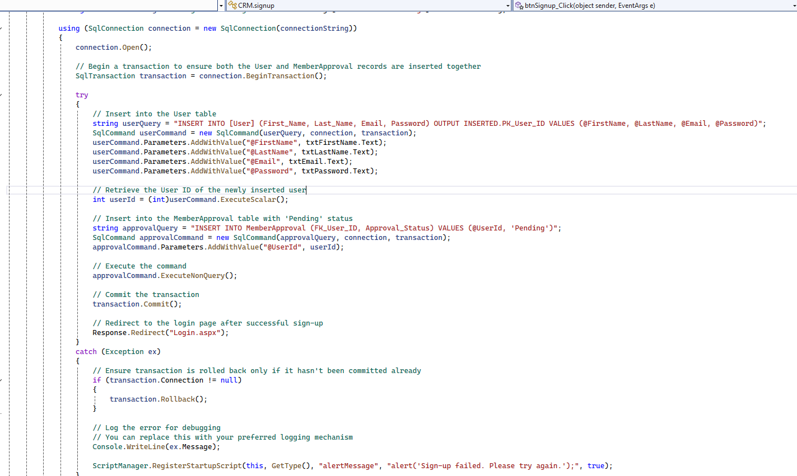

The author has written a SQL query to insert data into the database for the new user.

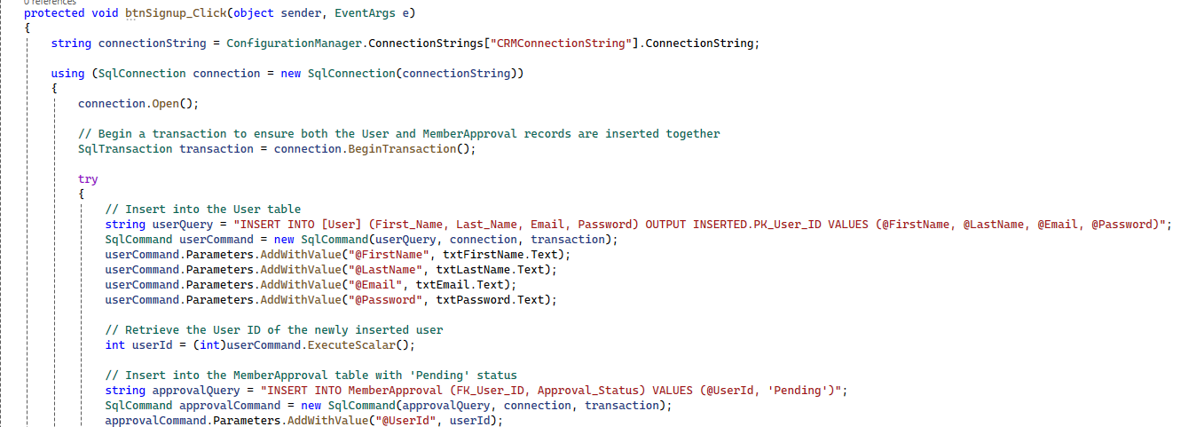

### Login

In login form author has implemented if statements to check if the information entered by the user is correct, if the connection to database is correct and if the query that must be executed is correct. If the user is authenticated and approved by the admin, it redirects to the member dashboard.

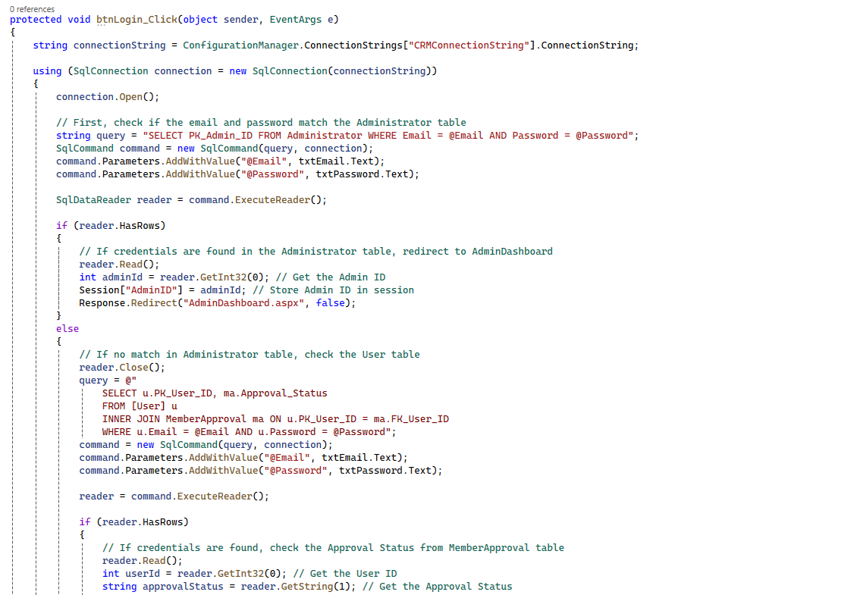

Separate checks for admin are implemented. If admin wants to login and the credentials are correct, he/she would redirect to the admin dashboard.

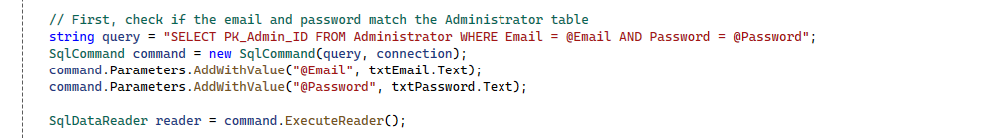

The author has implemented if statement to let only those user access the member dashboard that are approved by the admin.

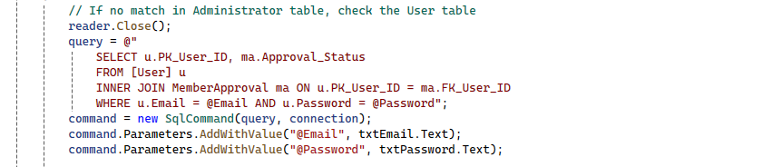

### Member Dashboard

The author has implemented Member Dashboard class for the authenticated members. Different checks are implemented to make sure that the user is logged in to access the member dashboard otherwise it would redirect to the login page.

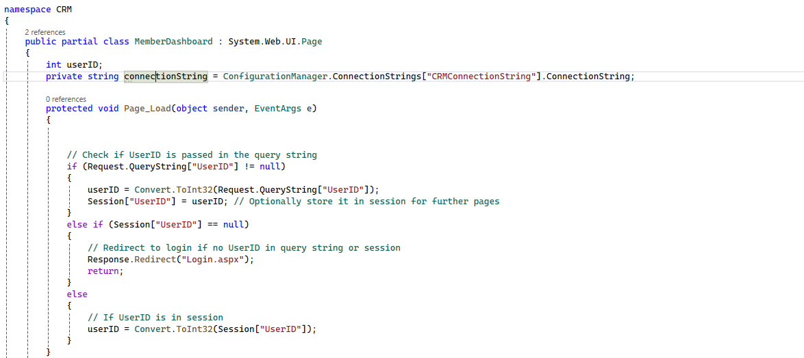

Different functions for different buttons are created that allows user to redirect the page they want.

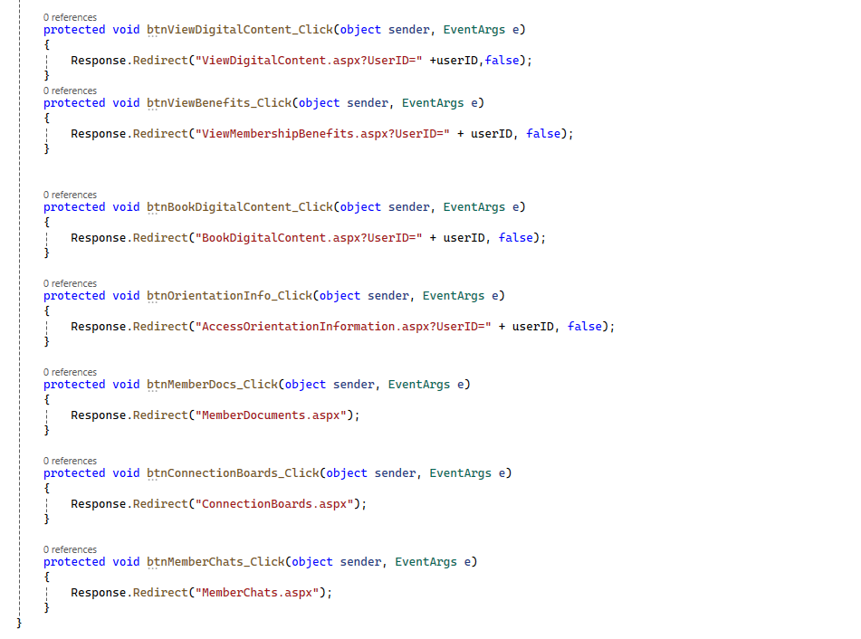

### View Digital Content:

The view digital content page on load checks if the user exists, if the user does not exist the system redirects to the login page. It also loads the digital content modules from the database.

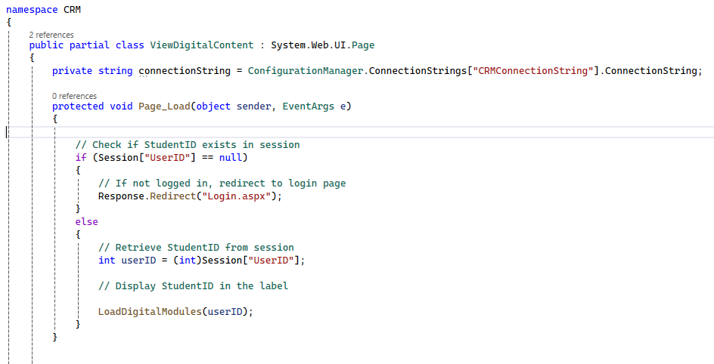

The following query loads the digital modules from the database and displays it to the user.

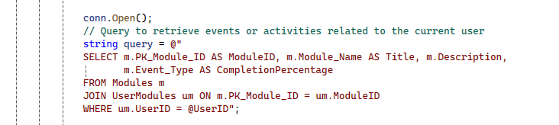

The functions in the image below are created by the author to let user redirect to the respective page.

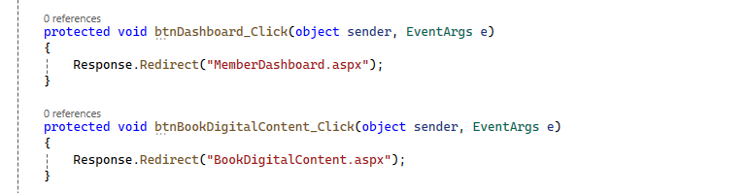

### Book Digital Content:

The author has implemented different checks that check if the user exists or not. if the user does not exist the system would redirect to the login page otherwise the available modules are loaded from the database.

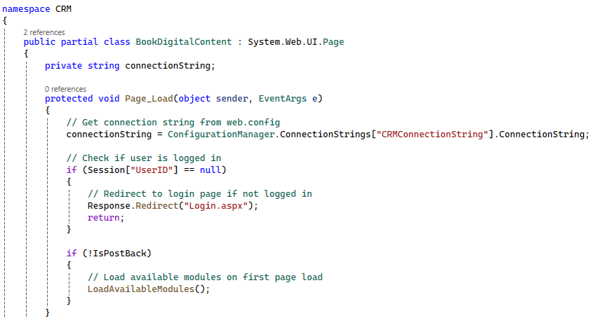

The following function has been created by the author that has a query fetching available modules from the database.

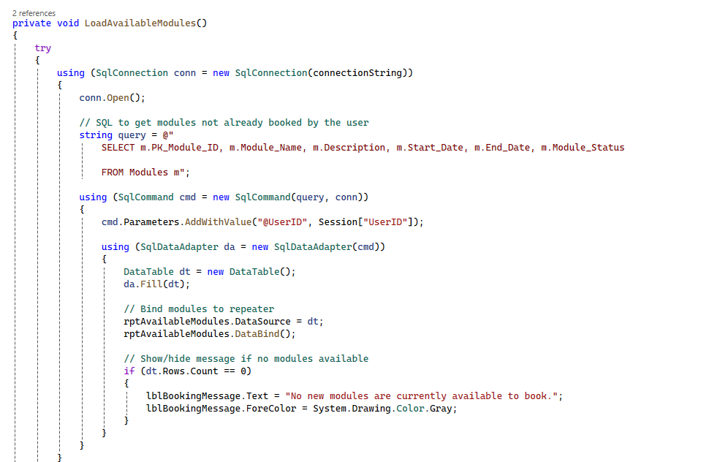

The following function has different checks to check if the user has selected any module or not. If the modules selected are not already booked by the user and at least one module is selected, modules are booked.

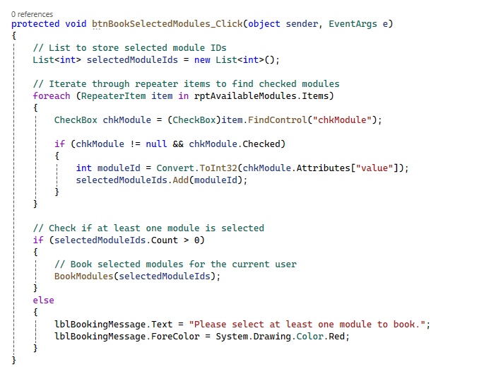

### Access Orientation Information:

The author has implemented checks to make sure that the current user exists in the database otherwise it redirects to the login page. If the user exists orientation information of that user is fetched from the database.

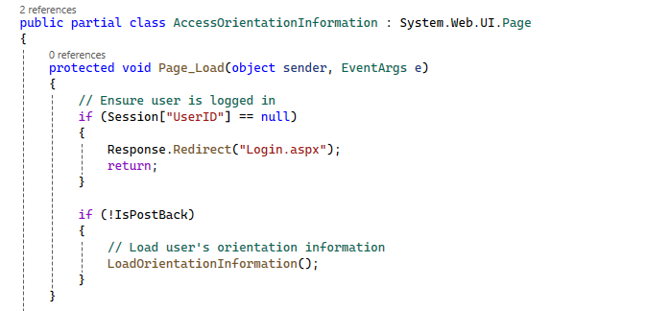

The following function has a query that fetches user’s orientation information from the database.

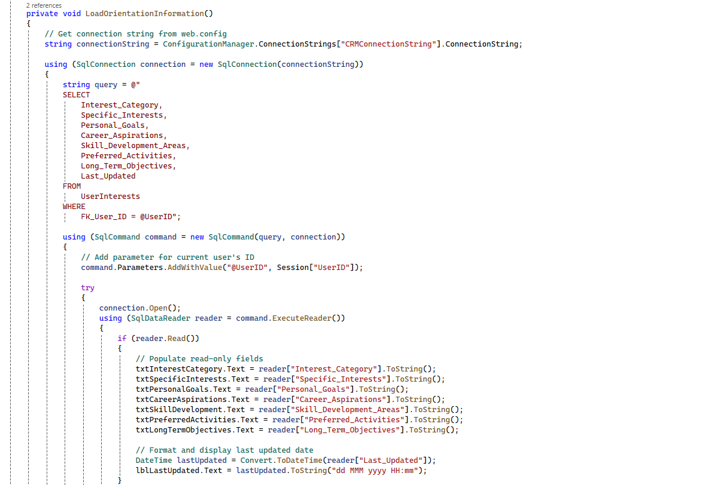

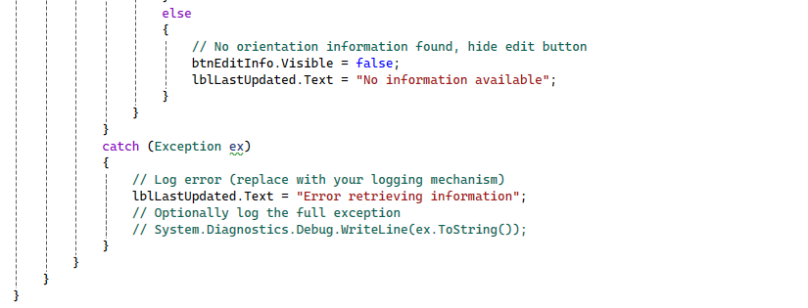

The following function allows user to edit their orientation information.

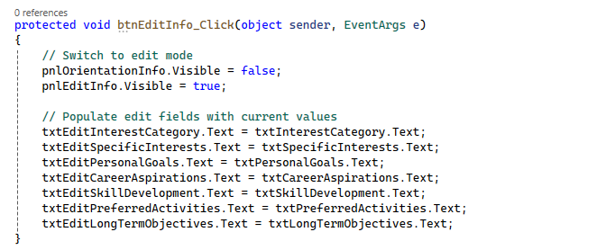

The author has created a button save changes function to save the edited information to the database.

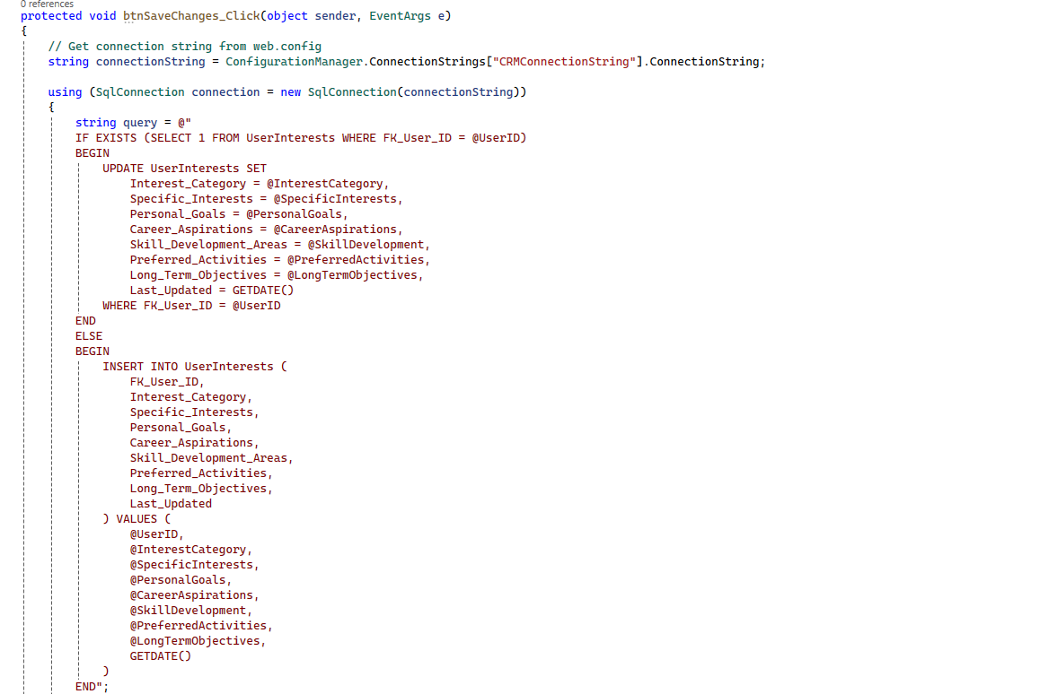

### Membership Benefits

The author has implemented checks to make sure that the current user exists and then a function that loads the membership benefits from the database.

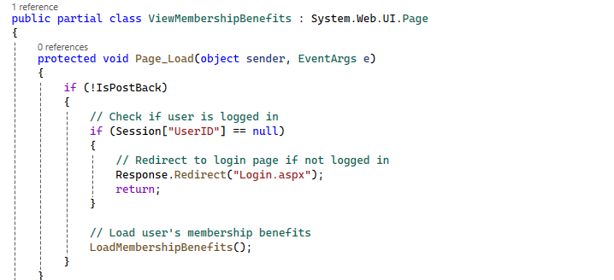

The author has created a load membership benefits function that loads membership benefits from the database and displays it to the user.

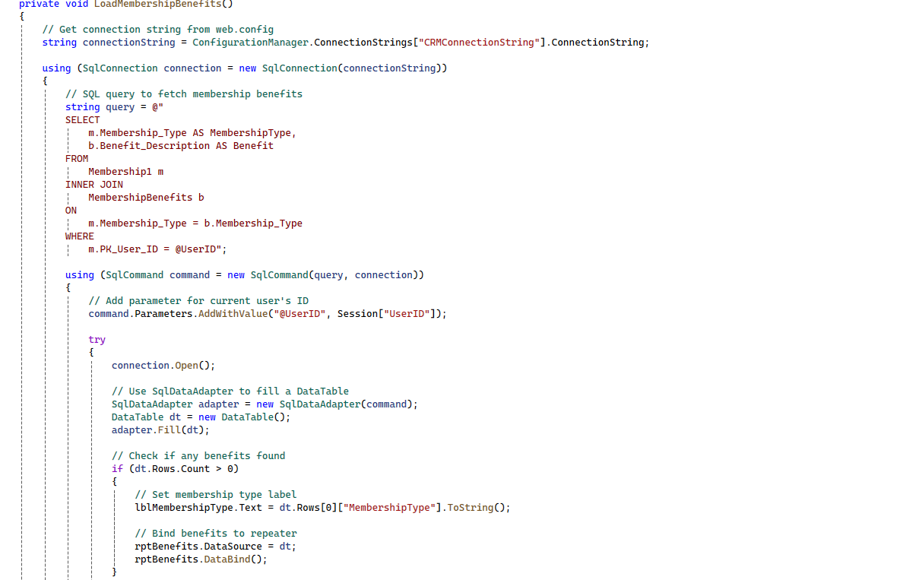

### Admin Dashboard

The admin dashboard in the backend loads the welcome message to the admin, load activity trends and loads members behavior from the database on the page load.

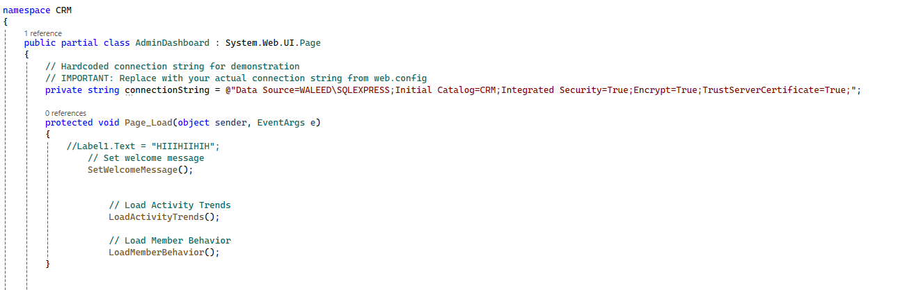

Load Activity Trends function is implemented that fetches data from the database and displays to the admin.

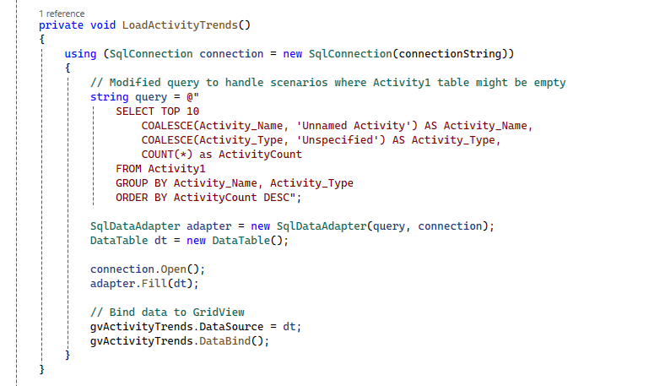

Similarly, Load Members Behavior function is implemented that fetches data from the database and displays it to the admin.

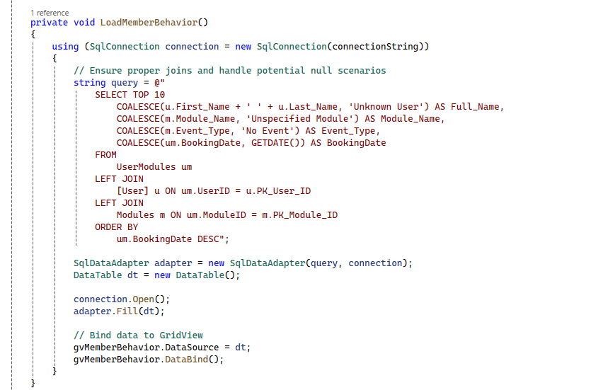

Different functions for different buttons are created allowing admin to only redirect to the page he/she wants.

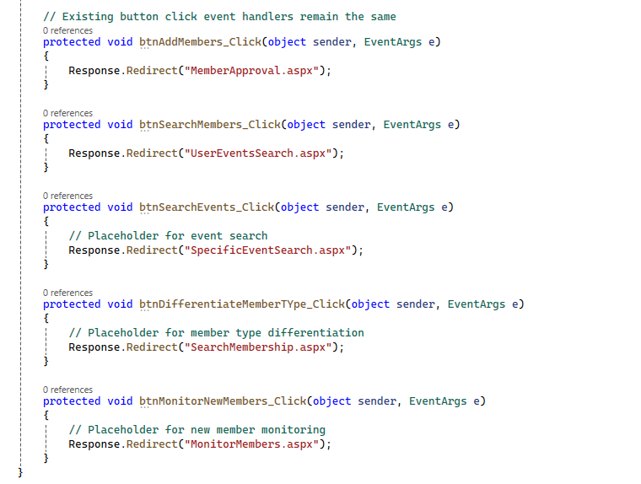

### Member Approval

The author has implemented different checks to make sure that the admin exists. If not, then the admin is redirected to the login page.

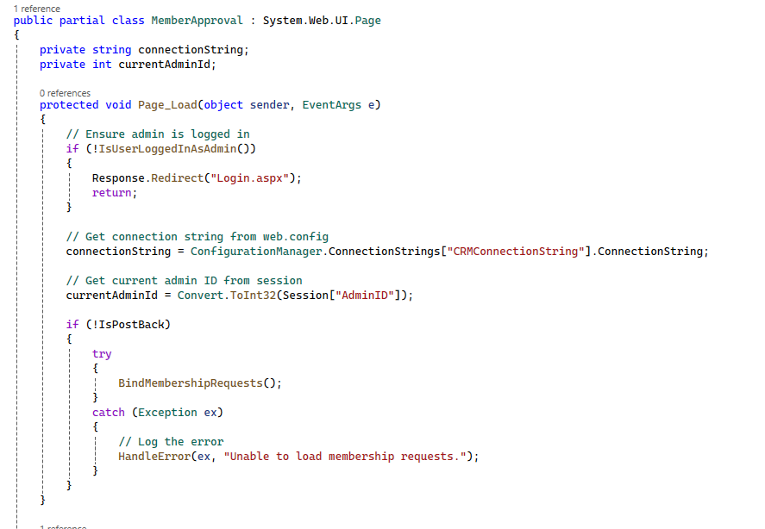

The author has implemented a function that has a query to retrieve the membership requests that are pending.

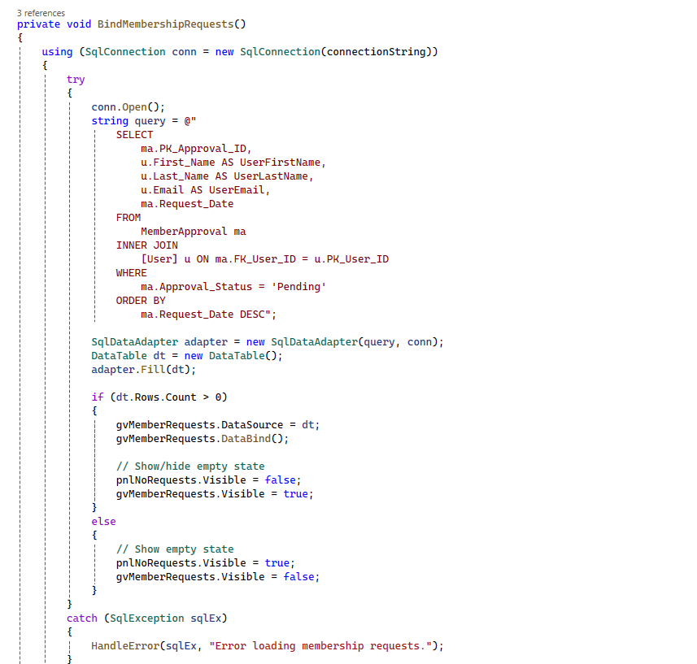

The author has implemented a function that binds the backend data with the frontend and shows to the admin.

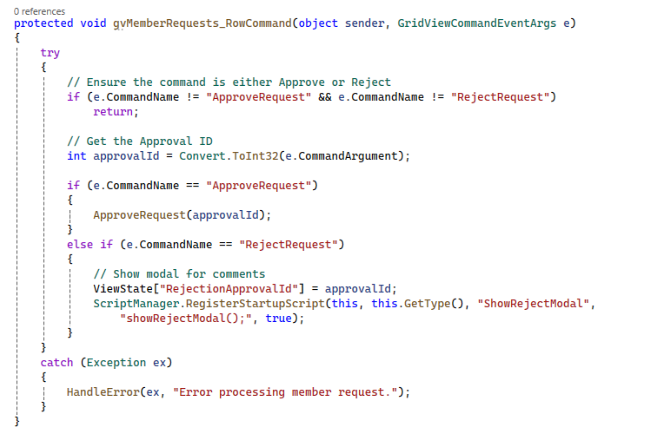

The following function updates the membership status of the user if accepted by the admin.

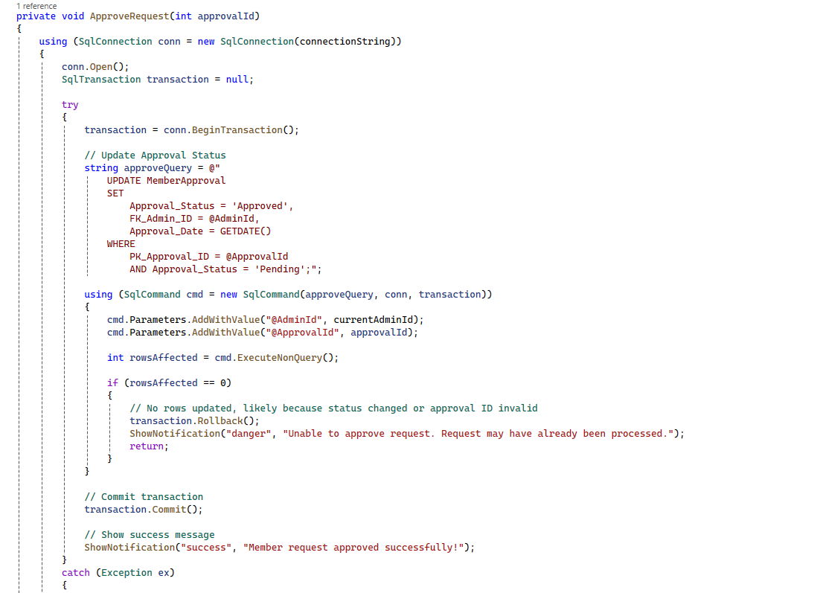

The following function updates the membership status of the user if rejected by the admin.

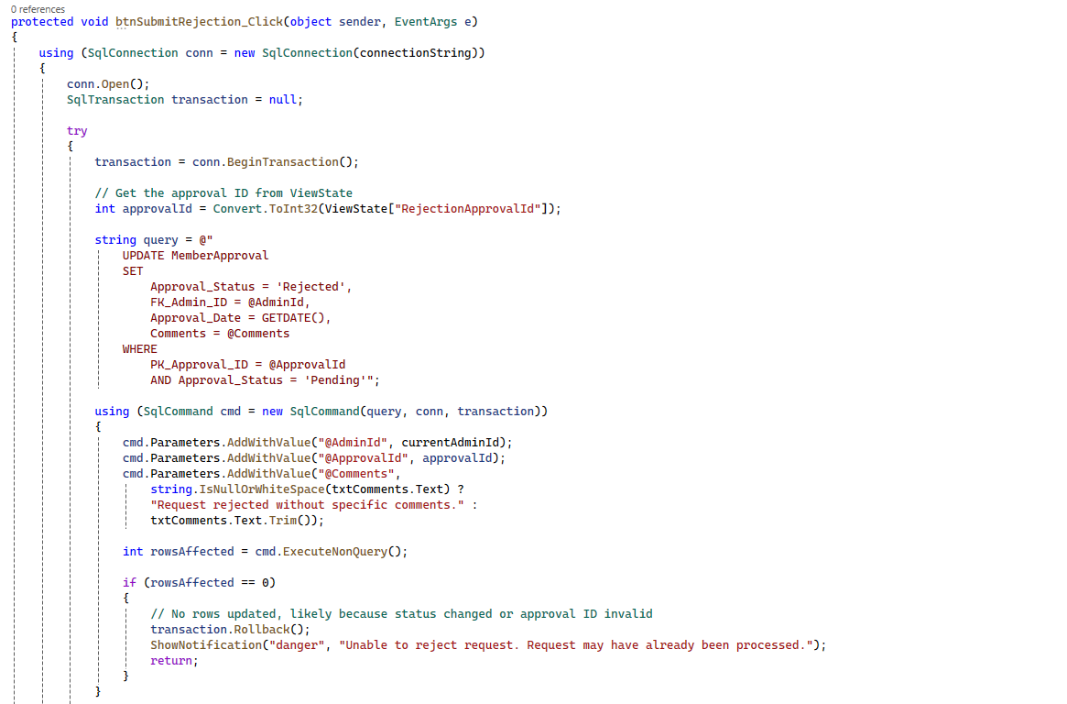

### User Events Search

The following function has a query that fetches the desired information from the database. It also bind the data to the table.

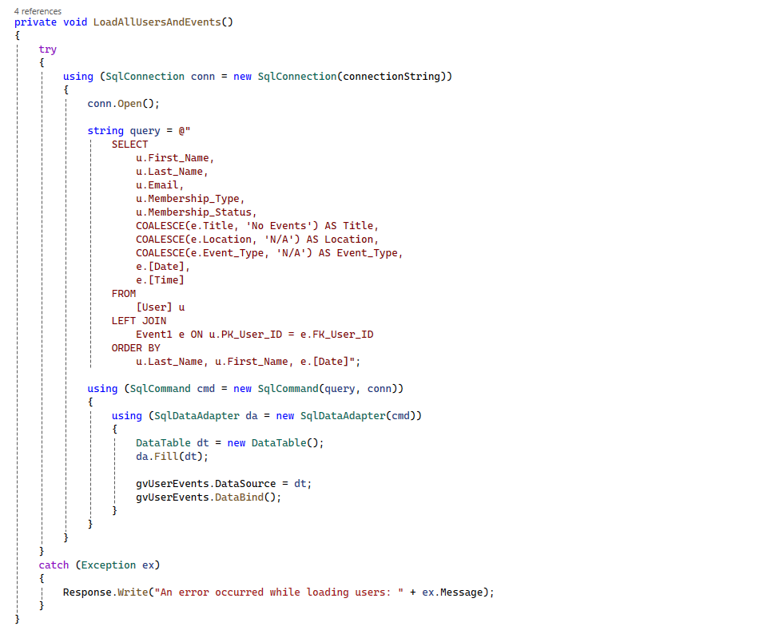

The following function has been implemented to clear the search and retrieve all the information from the database again.

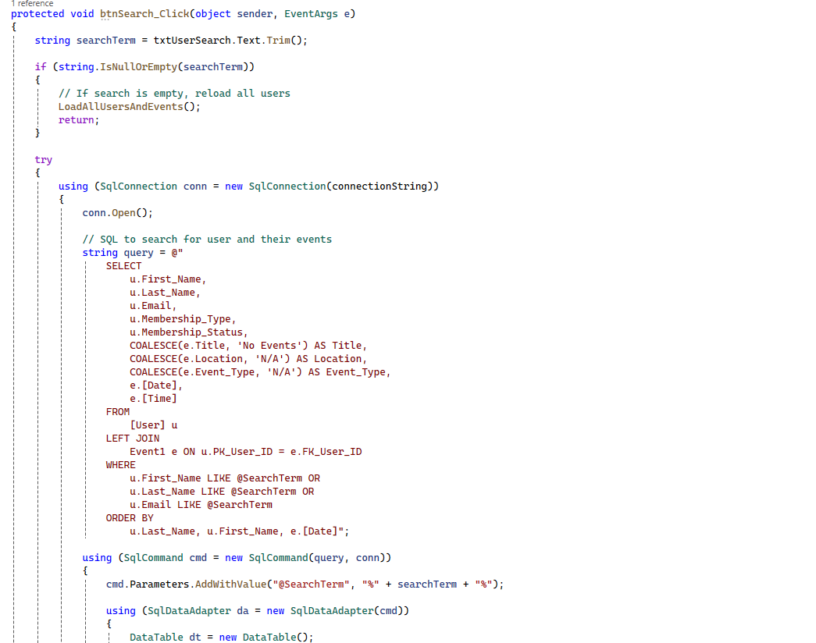

### Specific Search Event

The author has implemented a function that contains a query retrieving all users and events that are currently in the database.

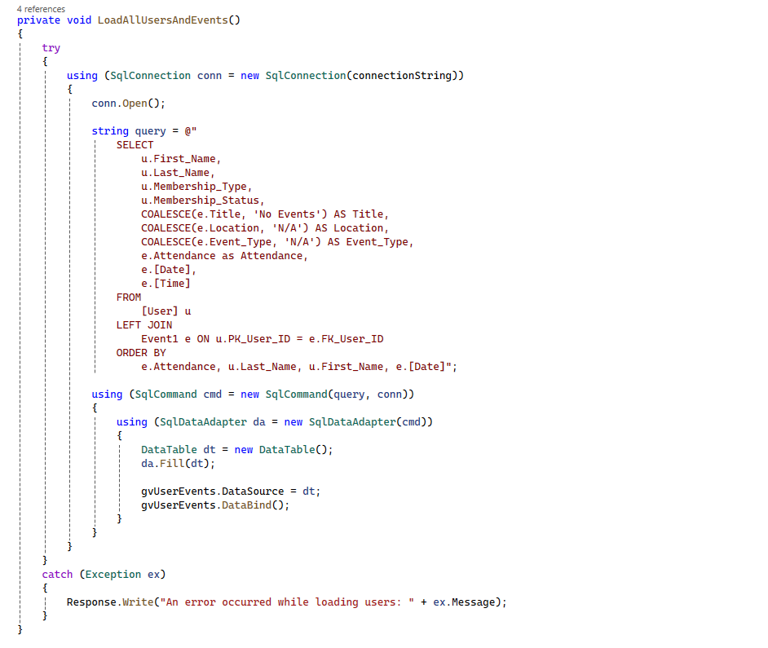

The author has implemented a function to search for the members on the basis of event type.

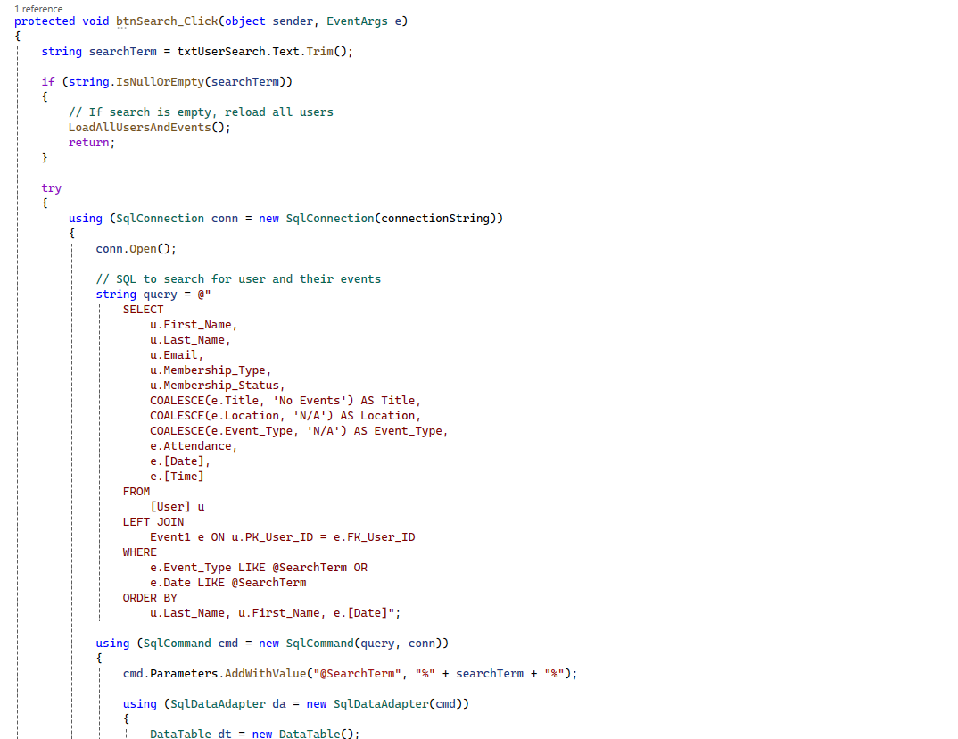

The author has also implemented a function that clear the search and shows all the users and events again.

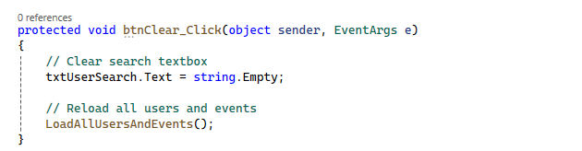

### Search Membership

The author has created a function that retrieves all the information about users and events from the database.

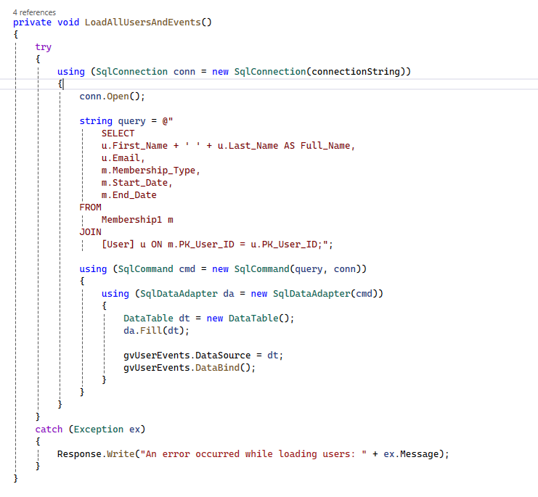

The following function has been implemented to search for members based on their membership types. It retrieves all the users for a specific search term.

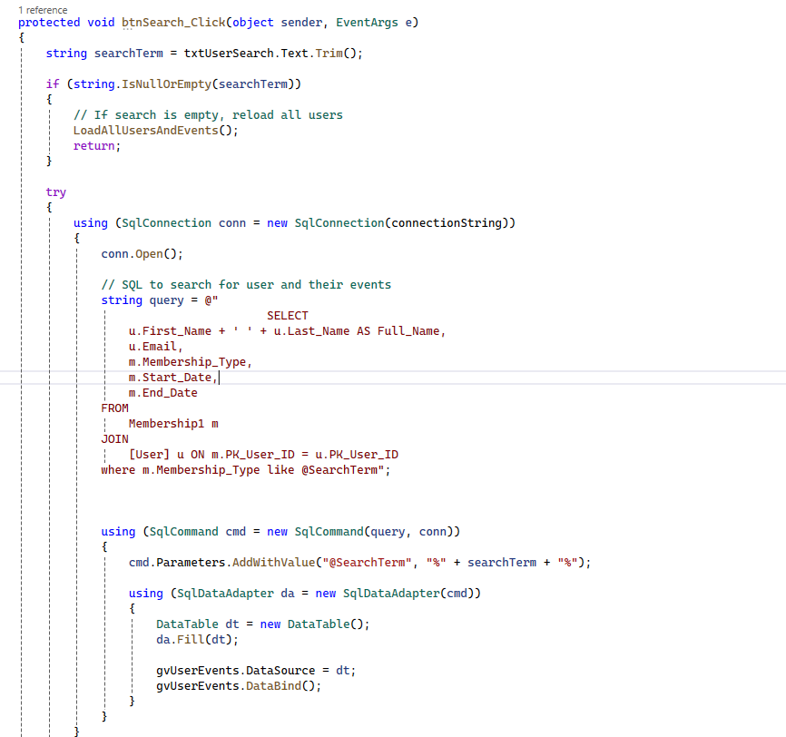

### Monitor Members

The author has implemented a function that contains a query to retrieve the desired information from the database and show it to the admin.

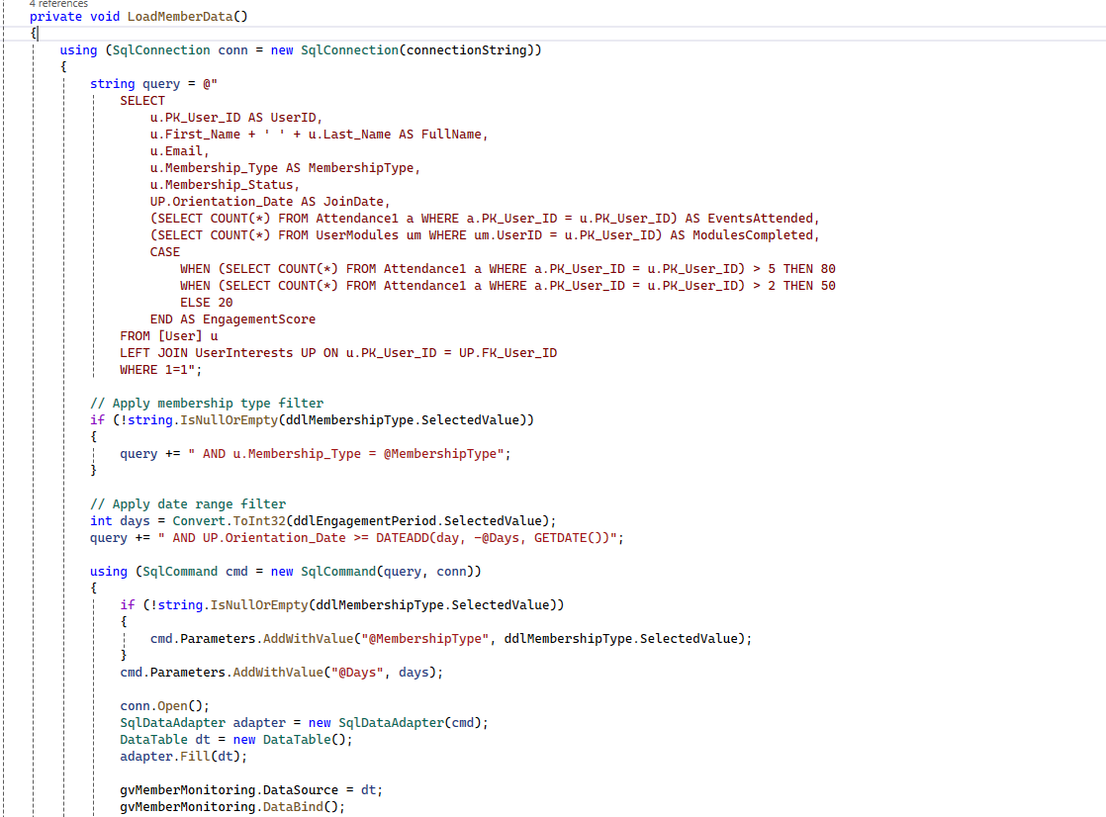

The following functions calculate the engagement score of the specific user and returns it.

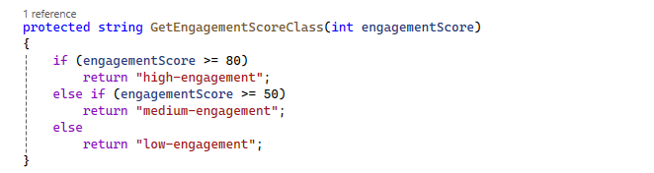

The following function on clicking view details button show the details of the specific user from the database.

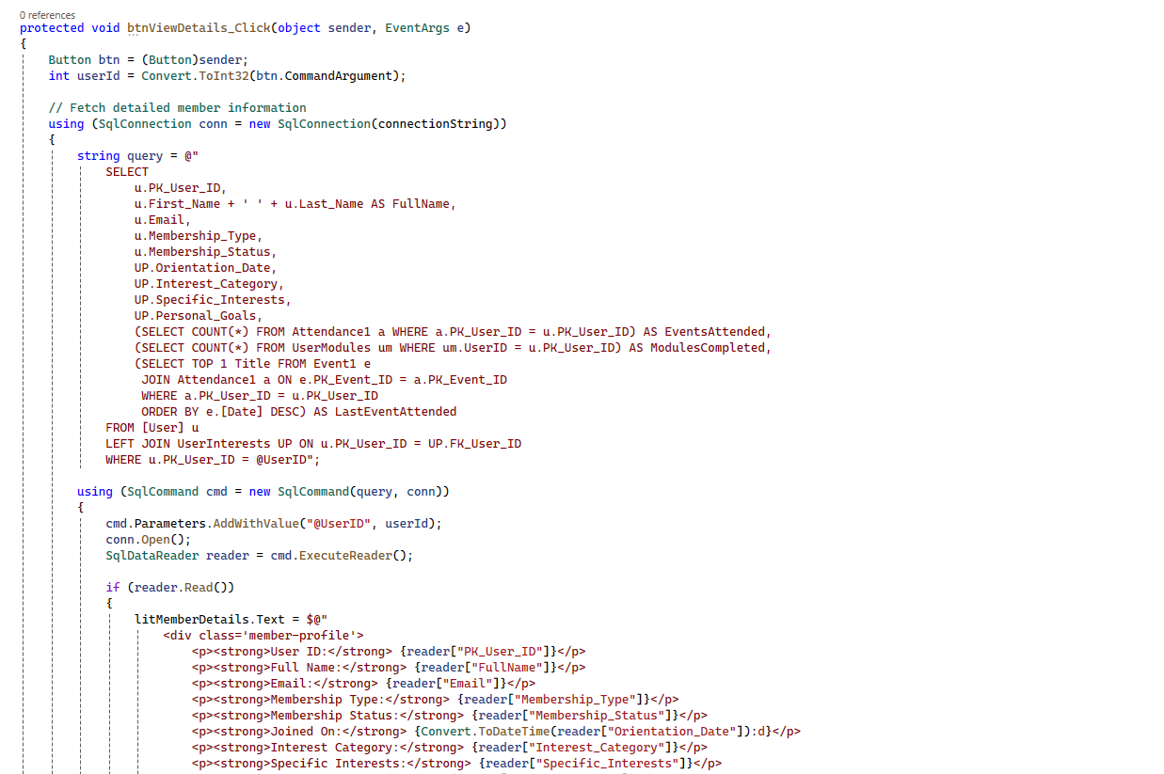

# 4. Testing:

|  |  |  |  |  |  |  |
| --- | --- | --- | --- | --- | --- | --- |
| Test No | Purpose | Class | Test Method | Expected Job | Result | Date |
| 1 | Attempt to create an account with first name field empty | Signup | Button_signup_click() | Sign in failed. Please try again. | Pass | 12/06/2024 |
| 2 | Attempt to create an account with last name field empty | Signup | Button_signup_click() | Sign in failed. Please try again. | Pass | 12/06/2024 |
| 3 | Attempt to create an account with email field empty | Signup | Button_signup_click() | Sign in failed. Please try again. | Pass | 12/06/2024 |
| 4 | Attempt to create an account with password field empty | Signup | Button_signup_click() | Sign in failed. Please try again. | Pass | 12/06/2024 |
| 5 | Attempt to create an account with wrong email format. | Signup | Button_signup_click() | Sign in failed. Please try again. | Pass | 12/06/2024 |
| 6 | Attempt to login without email | Login | btnLogin_Click() | Login failed. Please try again. | Pass | 12/06/2024 |
| 7 | Attempt to login without password | Login | btnLogin_Click() | Login failed. Please try again. | Pass | 12/06/2024 |
| 8 | Attempt to login with wrong email | Login | btnLogin_Click() | Login failed. Please try again. | Pass | 12/06/2024 |
| 9 | Attempt to login with wrong password | Login | btnLogin_Click() | Login failed. Please try again. | Pass | 12/06/2024 |
| 10 | Attempt to login without admin approval. | Login | btnLogin_Click() | Membership Request is pending with admin. Please try again later | Pass | 12/06/2024 |
| 11 | Attempt to login with membership request rejected | Login | btnLogin_Click() | Membership Request is rejected. | Pass | 12/06/2024 |
| 12 | Attempt to book modules without selecting any module | Book Digital Content | btnBookSelectedModules_Click() | Please select at least one module to book | Pass | 12/06/2024 |
| 13 | Attempt to book the modules that are already booked | Book Digital Content | btnBookSelectedModules_Click() | An error occurred while booking the modules. Please try again | Pass | 12/06/2024 |
| 14 | Attempt to view membership benefits with membership expired. | View Membership Benefits | LoadMembershipBenefits() | Error retrieving benefits | Pass | 12/06/2024 |
| 15 | Accept the request that already has processed | Member Approval | ApproveRequest() | Unable to approve request. Request may have already been processed. | Pass | 12/06/2024 |
| 16 | Reject the request that already has processed | Member Approval | RejectRequest() | Unable to approve request. Request may have already been processed. | Pass | 12/06/2024 |
| 17 | Trying to search members with search field empty | User Event Search | btnSearch_Click() | An error occurred during search | Pass | 12/06/2024 |
| 18 | Trying to search members other than name or email | User Event Search | btnSearch_Click() | An error occurred during search | Pass | 12/06/2024 |
| 19 | Trying to search members name that does not exist | User Event Search | btnSearch_Click() | An error occurred during search | Pass | 12/06/2024 |
| 20 | Trying to search members email that does not exist | User Event Search | btnSearch_Click() | An error occurred during search | Pass | 12/06/2024 |
| 21 | Trying to clear search with search field empty | User Event Search | btnClear_Click() | An error occurred in clearing search | Pass | 12/06/2024 |
| 22 | Trying to search members with search field empty | Specific Event Search | btnSearch_Click() | An error occurred during search | Pass | 12/06/2024 |
| 23 | Trying to search members other than event type or date | Specific Event Search | btnSearch_Click() | An error occurred during search | Pass | 12/06/2024 |
| 24 | Trying to search event types that does not exist | Specific Event Search | btnSearch_Click() | An error occurred during search | Pass | 12/06/2024 |
| 25 | Trying to search date that does not exist | Specific Event Search | btnSearch_Click() | An error occurred during search | Pass | 12/06/2024 |
| 26 | Trying to clear search with search field empty | Specific Event Search | btnClear_Click() | An error occurred in clearing search | Pass | 12/06/2024 |
| 27 | Trying to search members with search field empty | Search Membership | btnSearch_Click() | An error occurred during search | Pass | 12/06/2024 |
| 28 | Trying to search members other than membership type | Search Membership | btnSearch_Click() | An error occurred during search | Pass | 12/06/2024 |
| 29 | Trying to search membership types that does not exist | Search Membership | btnSearch_Click() | An error occurred during search | Pass | 12/06/2024 |
| 30 | Trying to clear search with search field empty | Search Membership | btnClear_Click() | An error occurred in clearing search | Pass | 12/06/2024 |

# 5. Maintenance:

# **CRM System Maintenance Plan for Together Culture**

# **Corrective Maintenance**

# Fix bugs like data retrieval errors, authorization issues, and booking failures.

# Monitor feedback, error logs, and perform regression testing after fixes.

# **Adaptive Maintenance**

# Upgrade dependencies (e.g., databases, frameworks) and ensure scalability.

# Implement new features (e.g., membership types, dashboards) and comply with updated policies (e.g., GDPR).

# **Perfective Maintenance**

# Optimize database queries and improve UI for better performance and usability.

# Refactor code for maintainability and update recommendation algorithms.

# **Preventive Maintenance**

# Conduct security audits, routine backups, and stress testing.

# Update security mechanisms to protect critical data.

# **Documentation Maintenance**

# Update manuals, technical documentation, and test cases.

# Maintain logs of updates, fixes, and enhancements.

# **Support and Training**

# Train admins on new features and provide member support via help desks and FAQs.

# **Monitoring and Reporting**

# Use monitoring tools for performance tracking and generate reports on system usage, member activity, and engagement.

# By following these practices, the CRM system will remain secure, scalable, and aligned with Together Culture's evolving needs.

# Conclusion:

# By offering a consolidated and effective platform for managing memberships, events, and community involvement, the CRM system created for Together Culture effectively addresses the issues noted in the original problem description. The initiative makes it possible for Together Culture to improve member service, expedite administrative duties, and obtain useful insights into member behavior and activity patterns by switching from a manual system to a digital one. Essential features like event scheduling, profile management, member registration, and tailored suggestions are all integrated into the system, guaranteeing a smooth and intuitive experience for administrators and members alike. By encouraging community participation and cooperation, features like skill exchange boards, tag-based searches, and encrypted chat capabilities further increase the platform's value. An iterative development process was assured by the project's adoption of Agile methodology, which allowed the system to change in response to user input and new needs. Class diagrams and well-defined use cases served as a roadmap for the design and implementation stages, guaranteeing that the technological architecture matched the organization's functional priorities. Its goal of creating a sustainable creative economy is supported by important administrative elements like event management, activity tracking, and member permission, which enable Together Culture to function effectively. The platform's flexibility and scalability also guarantee that it can handle future expansion and changing community demands.

# In summary, this project establishes the groundwork for ongoing innovation and development in addition to meeting Together Culture's present needs. In line with Together Culture's goal and vision, the CRM system is an essential tool for improving community participation, encouraging teamwork, and facilitating data-driven decision-making.

# References:

1. Together Culture, n.d. **Together Culture Cambridge**. [Online] Available at: <https://www.togetherculture.com/> [Accessed 6 November 2024] .
2. Agile Manifesto, 2001. **Manifesto for Agile Software Development**. [Online] Available at: <https://agilemanifesto.org/> [Accessed 15 November 2024] .
3. Google LLC, 2024. **Google Chrome**. Version 130.0.6723.70. [Software] Available at: <https://www.google.com/chrome/> .
4. Microsoft Corporation, 2016. **Microsoft Word for Windows**. Version 2016. [Software] Available at: [https://www.microsoft.com](https://www.microsoft.com/) .
5. Microsoft Corporation, 2016. **Microsoft Excel for Windows**. Version 2016. [Software] Available at: [https://www.microsoft.com](https://www.microsoft.com/) .
6. GitHub, 2024. **GitHub Desktop**. Version 3.4.8. [Software] Available at: <https://desktop.github.com/> .
7. Microsoft Corporation, 2024. **Visual Studio**. Version 1.94. [Software] Available at: <https://visualstudio.microsoft.com/> .
8. Visual Paradigm, Lucidchart, Draw.io, 2024. **Diagramming Tools**. [Software] Available at: [https://visual-paradigm.com](https://visual-paradigm.com/), [https://lucidchart.com](https://lucidchart.com/), [https://draw.io](https://draw.io/) .
9. Apache Friends, 2024. **XAMPP**. [Software] Available at: <https://www.apachefriends.org/index.html> .